Generative AI
1. Introduction to Generative AI
- What is Generative AI?
Generative AI is a type of artificial intelligence that can create new data or content such as text, images, audio, video, or code. Generative Artificial Intelligence is a field of AI that focuses on creating new and original data instead of just analyzing or recognizing existing information. It uses deep learning algorithms and neural networks to learn patterns, structures, and relationships from massive datasets and then generates completely new outputs that resemble the original data. For example, it can write essays, generate artwork, compose music, design graphics, or even write code. Unlike traditional AI systems that rely on fixed rules, generative AI models learn creatively from examples and can produce realistic, high-quality content on their own. Models like GPT, DALL·E, and Stable Diffusion have made generative AI one of the most revolutionary advancements in modern technology, capable of mimicking human imagination and creativity.
Examples include ChatGPT for text, DALL·E for images, and MusicGen for audio.
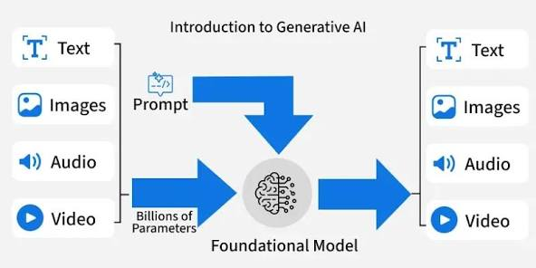
- Evolution of Generative AI
The evolution of generative AI has been a journey from simple data analysis to creative intelligence. In the early days, AI systems were rule-based, focusing mainly on classification and prediction tasks. As computing power and data availability increased, machine learning models became capable of identifying deeper patterns in data. The invention of Autoencoders allowed AI to learn compressed representations of data, and Generative Adversarial Networks (GANs), introduced in 2014, brought a breakthrough in generating realistic images. Later, Variational Autoencoders (VAEs) refined this process by introducing probabilistic latent spaces. In recent years, Diffusion Models and Transformer-based architectures like GPT have taken generative AI to new heights, enabling text, image, and multimodal generation with near-human quality. The biggest leap was the Transformer architecture (2017) by Google, leading to powerful large language models like GPT, Gemini, and Claude. Today, generative AI forms the backbone of advanced systems like ChatGPT, Midjourney, and Gemini, marking a new era where AI can not only analyze but also create.
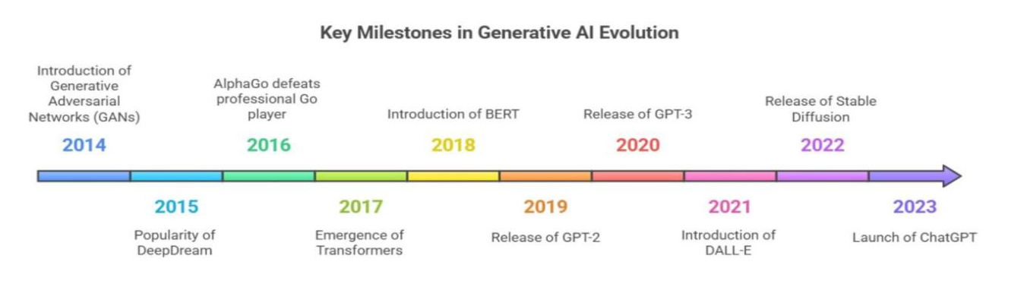
- Difference Between Predictive AI and Generative AI
Predictive AI and Generative AI differ mainly in their goals and functions. Predictive AI analyzes past data to make forecasts, classifications, or decisions about future outcomes for example, predicting sales, detecting fraud, or recognizing speech. Its role is to understand patterns and make accurate predictions. In contrast, Generative AI learns the underlying data distribution and uses that understanding to produce new and original outputs that didn’t exist before, such as creating a new design, writing an article, or generating an image. Predictive AI is about accuracy and recognition, while generative AI is about creativity and innovation. Essentially, predictive models answer “What will happen?”, whereas generative models answer “What can we create?”. This difference highlights how generative AI moves beyond logic to imagination, making machines capable of producing human-like creative work.
- Core Idea: Creation vs Classification
The fundamental difference between traditional AI and generative AI lies in their purpose and outcome. Traditional or predictive AI performs classification, meaning it identifies and labels input data. For example, a predictive model might recognize that a given picture is of a cat. Generative AI performs creation, meaning it produces something new, such as generating an entirely new image of a cat that never existed before. In creation, the model learns data distribution, while in classification, it learns decision boundaries. Generative AI thus goes beyond recognition to simulation mimicking how humans create new ideas from what they’ve seen before.This ability makes it valuable for tasks like content creation, storytelling, image synthesis, and design generation.
- Applications of Generative AI (Text, Images, Audio, Video, Code)
Generative AI is highly versatile and has applications across multiple data types:-
Text Generation: Tools like ChatGPT and Gemini write essays, code, summaries, and articles.
Image Generation: DALL·E, Midjourney, and Stable Diffusion create realistic or artistic images from text prompts.
Audio Generation: Models like Jukebox or MusicGen compose songs or recreate voices.
Video Generation: Tools like RunwayML and Sora generate videos directly from text or story board input.
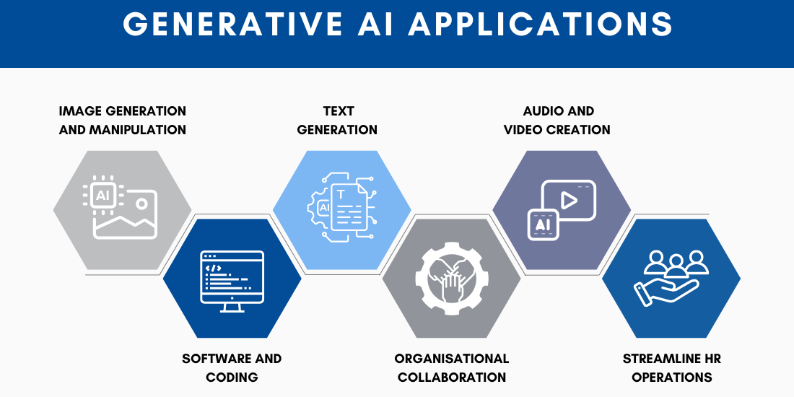
Code Generation: Codex, GitHub Copilot, and CodeLlama translate natural language to code. These applications are transforming industries such as education, entertainment, gaming, fashion, architecture, and marketing.

- Importance of Generative Models in the AI Era
Generative models play a crucial role in today’s AI-driven world by pushing the boundaries of what machines can create. They can produce realistic content, design products, and even simulate data for research and training. They enable automation in creative tasks that previously required human imagination, such as design, storytelling, and content production. Beyond creativity, they help in producing synthetic data for machine learning, which improves model training and preserves privacy. Generative AI also enhances personalization like generating tailored marketing campaigns, personalized education content, or customized digital art. In industries like healthcare, it’s used to simulate medical images and drug molecules for research. These models not only save time and cost but also open new possibilities in innovation, making them a cornerstone of the modern AI era. Their impact is comparable to the invention of the internet transformative, wide-reaching, and constantly evolving.
- Real-World Use Cases (ChatGPT, DALL·E, Midjourney, Gemini, Claude)
Generative AI is already powering some of the world’s most advanced tools and applications.
ChatGPT by OpenAI generates conversational text, helping users write, code, and learn.
DALL·E, also from OpenAI, creates high-quality images from simple text prompts, enabling creative design with minimal effort.
Midjourney specializes in artistic and stylistic visuals, popular among designers and digital artists.
Gemini by Google DeepMind combines text, image, and video understanding in a multimodal framework.
Claude by Anthropic focuses on safe, ethical, and context-aware text generation. These real-world tools demonstrate how generative AI can enhance creativity, improve productivity, and provide intelligent assistance in day-to-day tasks.
- Generative AI Ecosystem Overview (Models, Frameworks, Tools)
The generative AI ecosystem is made up of interconnected components that enable building, training, and deploying intelligent models. Models like GPT (for text), Diffusion and GANs (for images), and Whisper (for audio) form the foundation. These models are built using frameworks such as TensorFlow and PyTorch, which support large-scale training and optimization. Libraries like Hugging Face Transformers and Diffusers provide pre-trained models that developers can adapt for their own use. Tools like LangChain and LlamaIndex help connect language models with data sources for advanced applications, while Gradio and Streamlit allow developers to create user interfaces for AI apps. Deployment platforms like OpenAI API, Stability AI, and ComfyUI make these technologies accessible to everyone. Together, they form a dynamic ecosystem that powers the global growth and accessibility of generative AI.
2. Foundations of Generative Models
- What Are Generative Models?
Generative models are a type of artificial intelligence system that learns how data is created so it can generate new data that looks and feels similar to real examples. Instead of just identifying or classifying information, they learn the underlying patterns, relationships, and structures within a dataset. For example, if trained on thousands of pictures of landscapes, a generative model can create completely new, realistic-looking landscapes that don’t exist in the real world. These models use deep learning and neural networks to analyze data distributions and build an internal understanding of how data points relate to each other. Once trained, the model can generate new samples that belong to the same distribution. Generative models are the foundation of creative AI applications such as ChatGPT (text generation), DALL·E (image generation), Whisper (audio transcription), and Copilot (code generation). Their ability to produce original content has made them revolutionary in art, media, research, and business.
- Generative vs Discriminative Models
AI models are broadly divided into discriminative and generative types.
A discriminative model focuses on learning boundaries between data categories — for example, it can identify whether an image is of a cat or a dog. It predicts a label or output based on given input data and is used for classification or prediction tasks.
A generative model, however, learns how data is formed and distributed. It captures the joint probability between input and output variables, which allows it to create new data points similar to the original dataset.
For example, a discriminative AI can tell you this is a dog, while a generative AI can draw a new dog that doesn’t exist yet. Discriminative models are great for accuracy and recognition, while generative models are great for creativity and simulation. Together, they complement each other one understands the world, and the other recreates it.

- Probabilistic Modeling Basics
Generative AI lies probabilistic modeling, which helps the system handle uncertainty and randomness in data. Probabilistic modeling is the mathematical foundation of generative AI. It involves representing data and uncertainty using probability distributions. Every dataset whether it’s text, images, or audio can be thought of as samples drawn from an unknown probability distribution. A generative model tries to learn this hidden probability distribution, so it can later generate new data points that fit naturally within it. This process makes the generated content look believable and varied instead of repetitive.
For example, after learning what patterns and colors usually appear in pictures of sunsets, it can generate new sunsets that look real. This concept helps the AI system maintain variety, randomness, and realism, avoiding repetition or identical results. Probabilistic modeling is what gives generative AI its “creative variability,” allowing it to produce unique outputs each time.
- Latent Variables and Representations
Latent variables are hidden or unseen features within data that describe its most important characteristics. For example, in an image of a face, latent variables could represent things like hair color, age, or expression. Generative models use a latent space, a special compressed zone where these hidden features are stored and organized. Generative models convert complex input data into a compact, lower-dimensional latent space, which acts like a “map” of the data’s hidden properties. When the AI wants to generate something new, it selects points in this space and transforms them back into real outputs. By adjusting these variables, the AI can control the style, tone, or structure of the output like making a person smile or changing a photo’s color. This concept helps generative AI understand not just data itself, but the essence behind it, enabling flexible and creative generation. It’s one of the most powerful ideas behind how AI can “imagine” new versions of existing things.
- Sampling and Density Estimation
Sampling and density estimation are key techniques in how generative AI produces new data. Sampling means the model takes examples from what it has learned to generate something new like picking random points from a pattern. Density estimation measures how close the generated data is to real data, ensuring that the outputs look natural. Together, these steps help maintain a balance between creativity and realism. Good sampling ensures that generated outputs are both realistic and diverse, while density estimation ensures the model doesn’t stray too far from reality. For instance, when generating text, AI samples one word at a time based on probability, ensuring the sentence makes sense. In image generation, sampling helps create fine details, while density estimation keeps them natural-looking.If sampling is done too randomly, results may look fake; if it’s too strict, the model may repeat itself. By mastering this process, AI can create realistic text, images, and sounds that feel authentic to humans. Essentially, sampling gives generative AI its creative freedom, while density estimation keeps it believable.
- Maximum Likelihood Estimation (MLE)
Maximum Likelihood Estimation (MLE) is a mathematical method used to train generative models. The idea is to adjust the model’s internal parameters to maximize the likelihood that the model would produce the real observed data. It works by finding the set of model parameters that make the real training data most probable. In simpler terms, the model adjusts itself so that it becomes better at reproducing real examples. Each time it learns, it slightly changes its internal settings to increase the likelihood of generating data similar to the training set. MLE ensures that the model doesn’t just generate random noise but realistic, structured outputs. It’s one of the most stable and widely used techniques in training deep learning systems, including generative AI. By using MLE, AI learns to think statistically like humans, understanding what “fits” and what doesn’t.
- Energy-Based and Autoregressive Models
Energy-based and autoregressive models are two important approaches in generative AI. Energy based models assign energy scores to possible outputs lower energy means the result looks more natural or real. They try to find outputs with the least “energy,” which usually correspond to realistic data. Autoregressive models, such as GPT, generate data one step at a time predicting the next word, pixel, or sound based on the previous ones. This sequential generation process helps them maintain logical consistency and natural flow. Energy-based models are great for generating complex data distributions, while autoregressive models excel in sequence generation such as language, audio, and time-series data. This step-by-step process helps AI create smooth, logical sequences like human language or continuous music. Together, these approaches allow AI to produce data that’s structured, coherent, and life like. They’re especially powerful for generating text, audio, and time-based data such as speech or music.
- Overview of Key Model Families:
There are four main families of generative models used in AI today.
  - Variational Autoencoders (VAEs)
Variational Autoencoders (VAEs) Learn compressed representations (latent spaces) of data and then reconstruct similar outputs. They’re used for tasks like image reconstruction and feature learning.
  - Generative Adversarial Networks (GANs)
Generative Adversarial Networks (GANs) use two neural networks one creates data, and the other judges it improving realism through competition. Use a generator and discriminator that compete with each other to produce ultra-realistic results, especially in images.
  - Diffusion Models
Diffusion Models start with random noise and gradually refine it into detailed images, used in tools like Stable Diffusion(used in Stable Diffusion and Midjourney).
  - Transformer-Based Models (LLMs)
Transformer Models, like GPT, rely on attention mechanisms to generate high-quality text, code, and even images.
Each family has unique strengths — VAEs for learning structure, GANs for realism, Diffusion for detail, and Transformers for versatility.Together, they make up the foundation of today’s generative AI systems used across industries.
3. Core Mathematics and Concepts
- Probability and Statistics for Generative AI
Probability and statistics form the mathematical foundation that allows generative AI to understand patterns and make decisions about what to create next. In generative modeling, AI assumes that all data whether text, images, or sounds is generated from some hidden probability distribution. The goal of the model is to learn this distribution accurately, so it can later produce new data that fits naturally within it. For example, ChatGPT predicts each next word in a sentence by estimating which word is most probable based on the previous ones. Similarly, image generators like Stable Diffusion learn which color or shape combinations are most likely to appear together in real photos. Statistics help the model understand averages, variances, and correlations in data, while probability enables it to handle uncertainty and randomness.Together, they allow AI to balance realism and creativity, producing content that looks both authentic and unique. Without probability and statistics, AI would be unable to handle variations or generate believable, human-like results. They help ensure that every output whether it’s a sentence or an image feels natural, logical, and contextually correct.
- Linear Algebra for Model Representations
Linear algebra is the core mathematical tool that makes deep learning and generative AI possible. It deals with vectors (lists of numbers), matrices (grids of numbers), and tensors (multi-dimensional data). In generative AI, all information words, pixels, sounds is represented as numerical vectors that capture their meaning or properties. For example, in language models, each word is converted into a vector that represents its context and relationships with other words (like “king” and “queen” being close in vector space). When data passes through a neural network, it undergoes matrix multiplications and linear transformations that adjust these values to create meaningful outputs. This process helps the model learn complex patterns and relationships in high-dimensional data. For image generation, linear algebra helps represent and modify features like color, brightness, and edges. In large models like GPT, millions of matrices work together to encode, transform, and decode data. Eigenvectors, eigenvalues, and vector spaces help AI compress large data and extract only the most important information.
- Optimization in High-Dimensional Spaces
Optimization is the process of improving the model’s performance by finding the best set of parameters (or weights) that minimize error. Generative AI models often have millions or even billions of parameters, forming a very large and complex “space” of possible configurations. Optimization algorithms like Gradient Descent help the model adjust these parameters step by step to make its predictions or creations more accurate. Each step moves the model closer to the best version of itself the one that produces realistic, high-quality results. This process is like finding the lowest point in a massive, multi-dimensional landscape, where the lowest point represents the model’s optimal settings. However, since the landscape is so large, optimization techniques must be smart and efficient to avoid getting stuck in wrong spots (local minima). Learning rates, batch sizes, and regularization methods are all tuning tools that help with stable optimization. In generative AI, optimization ensures the model generates realistic and consistent data while maintaining diversity. Without optimization, even the most powerful models would fail to learn meaningful patterns or produce coherent outputs.
- KL Divergence and Cross-Entropy
Kullback–Leibler (KL) Divergence and Cross-Entropy are key mathematical tools used to measure the difference between two probability distributions. In simple terms, they tell us how far the model’s generated data distribution is from the real data distribution. KL Divergence quantifies how one distribution diverges from another for example, how different the AI’s generated images are from real ones. It’s used heavily in Variational Autoencoders (VAEs) and Diffusion Models to push the model toward generating more realistic data. Cross-Entropy, on the other hand, measures how well a model predicts the correct output. In text generation, it compares the predicted next word probabilities to the actual next word and penalizes errors. Lower cross-entropy means better predictions, more natural text, and improved accuracy. Both KL Divergence and Cross-Entropy help guide model training, ensuring it learns the correct patterns instead of memorizing wrong ones. They act like a compass for the AI, steering it toward realism, accuracy, and coherence during generation.
- Variational Inference
Variational Inference (VI) is a mathematical approach used when dealing with complex probability distributions that are difficult to compute directly. Instead of calculating exact probabilities (which can be impossible for large models), VI estimates them using simpler, easier-to-handle functions. In generative AI, it helps models like VAEs approximate hidden or latent variables the unseen factors that define data. For example, when training on faces, the AI might learn latent variables like “smile,” “age,” or “lighting.” VI allows the model to efficiently learn these hidden patterns and generate new, realistic examples based on them. This approach balances accuracy and computational efficiency, letting AI handle massive, high-dimensional datasets. Without variational inference, modern generative models would be too slow or unstable to train effectively. It’s a smart shortcut that enables AI to approximate creativity mathematically.
- Loss Functions in Generative Models (Reconstruction Loss, Adversarial Loss, KL Loss)
Loss functions measure how well or poorly a model is performing they act like feedback or grades for AI during training. The goal of training is to minimize the loss, meaning the model’s predictions become closer to real data.
Different generative models use different types of loss functions:
Reconstruction Loss (used in VAEs) measures how close the generated output is to the original input.
Adversarial Loss (used in GANs) measures how well the generator fools the discriminator.
KL Loss helps maintain realistic latent spaces by keeping generated distributions close to real ones.
By combining these losses, models can learn to create both accurate and diverse outputs. Loss functions guide the entire learning process without them, the model wouldn’t know how to improve. They are the bridge between mathematics and creativity in generative AI.
- Gradient Descent and Backpropagation Refresher
Gradient Descent and Backpropagation are core learning algorithms in all deep learning models, including generative AI. Gradient Descent updates model parameters step by step to minimize the loss function, moving toward better accuracy. Backpropagation calculates how much each parameter contributed to the error, allowing targeted corrections. Together, they allow AI models to learn efficiently from data through repeated trial and error. In generative AI, this process helps the model refine its ability to produce realistic text, images, or sounds with every iteration. Think of it like sculpting each gradient update chips away errors, making the final output smoother and more accurate. These algorithms make it possible for models like GPT or Diffusion to improve steadily and creatively over time.
- Random Sampling and Noise Injection Techniques
Generative AI relies heavily on randomness to make outputs diverse and natural. Random sampling introduces variability by allowing the model to explore different possible outputs instead of repeating the same thing. Noise injection adds small random disturbances during training, helping the model learn to remove or interpret noise in meaningful ways. Diffusion Models, for instance, start by adding noise to an image and then learn how to reverse the process to recover it generating entirely new, realistic visuals. These techniques prevent overfitting, encourage creativity, and ensure that AI doesn’t just memorize examples but actually learns how to “create.” Without randomness, every AI-generated image, text, or song would look identical. Controlled randomness, therefore, gives AI its artistic touch — the ability to surprise us while staying believable.
4. Variational Autoencoders (VAEs)
- Introduction to Autoencoders
An Autoencoder is a type of neural network designed to learn efficient representations of data by compressing and reconstructing it. It consists of two main parts: an Encoder that reduces data into a smaller, meaningful form, and a Decoder that tries to recreate the original data from that compressed version. The goal is to teach the network how to capture the most important information while ignoring noise or unnecessary details. For example, if we feed an image into an autoencoder, it will learn to recognize key features like shapes and colors while ignoring minor pixel noise. Autoencoders are trained using reconstruction loss, which measures how close the reconstructed output is to the original input. They are often used for data compression, noise removal, dimensionality reduction, and feature learning. While traditional autoencoders are deterministic meaning they always produce the same output for a given input they are limited in creativity. They can only reconstruct data they’ve seen, not generate truly new examples. That’s why the Variational Autoencoder (VAE) was introduced it adds randomness and probability, allowing AI to create new data. In short, autoencoders teach AI how to understand and rebuild data, forming the foundation for generative creativity.
- Encoder-Decoder Architecture
The architecture of a Variational Autoencoder is divided into two neural networks the Encoder and the Decoder. The Encoder takes the input data (like an image or text) and compresses it into a smaller numerical form known as the latent vector. This process captures the key features of the data, removing less important details. Then the Decoder takes this latent vector and reconstructs the original data as closely as possible. Together, the Encoder and Decoder work like a translator one encodes information into a compressed “language,” and the other decodes it back into a meaningful form. In a VAE, however, the Encoder doesn’t just produce a single value; it predicts two vectors the mean (μ) and standard deviation (σ) representing a probability distribution. This allows the model to sample different possible representations of the same input, adding randomness to the process. The Decoder then learns to rebuild data even from slightly different latent samples, giving the model creative flexibility. This two-part structure makes VAEs excellent at learning compressed, smooth, and meaningful representations of complex data.
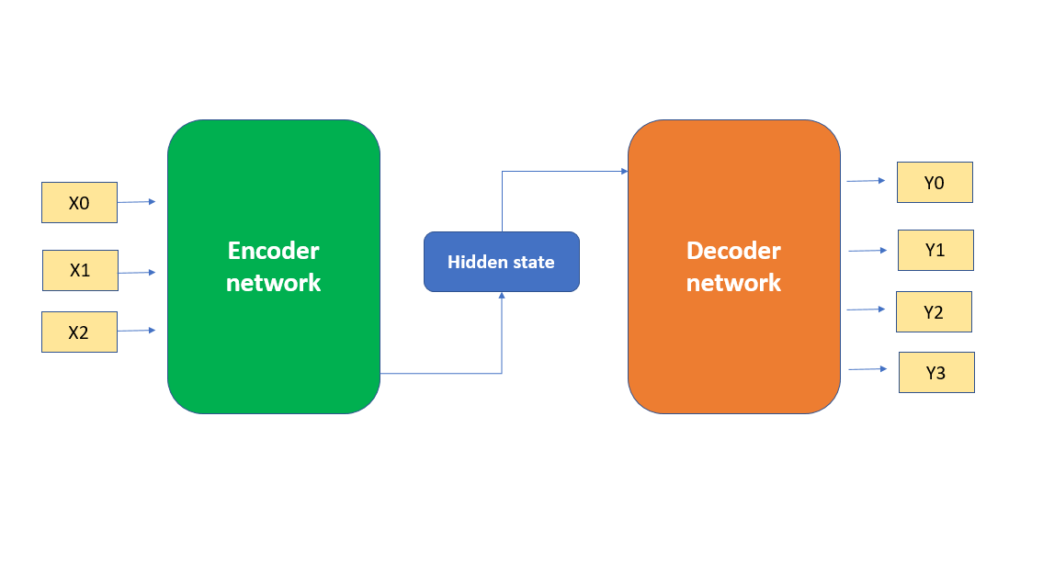
- Bottleneck Layer and Latent Space Representation
At the center of the encoder-decoder structure lies the bottleneck layer, which holds the latent space representation of the input. This bottleneck acts as a narrow passage that forces the model to retain only the most important information. Imagine it as squeezing a high-resolution image into a small summary of its features the model must learn which details truly matter. The latent space is a multidimensional space where each point corresponds to a possible version of the input data. Nearby points represent similar data for instance, two points close together might both represent smiling faces. This space allows the AI to explore variations smoothly; by moving slightly through it, the model can create new but realistic samples. The latent space is what gives VAEs their creative control by manipulating latent variables, we can modify outputs (like changing a person’s age or background in a generated image). This concept of compressing, representing, and expanding data is at the heart of all generative AI models today.
- Regularization using KL Divergence
To make sure the latent space is well-organized and continuous, VAEs use a technique called regularization, based on Kullback–Leibler (KL) Divergence. KL Divergence is a mathematical measure of how one probability distribution differs from another. In VAEs, it ensures that the learned latent variables follow a normal (Gaussian) distribution a smooth, continuous space without gaps or clusters. This regularization helps prevent the model from overfitting or memorizing individual training examples. The KL term in the loss function keeps the latent vectors evenly spread out, so every region in latent space can generate meaningful outputs. It also ensures that similar data points are located close together in latent space, which makes interpolation (blending features between examples) smooth and natural. Without this regularization, the latent space would be messy and unpredictable, causing unstable or unrealistic generations. Thus, KL Divergence acts as a “teacher,” guiding the model to organize its imagination logically.
- Reparameterization Trick
One challenge in training VAEs is that sampling from a probability distribution is not directly differentiable meaning the model can’t easily learn from it using gradient descent. To solve this, the Reparameterization Trick was introduced. Instead of sampling directly from the distribution, the model separates randomness from learning by using the formula:
z = μ + σ * ε, where μ is the mean, σ is the standard deviation, and ε is random noise drawn from a normal distribution.
This allows the model to keep gradients flowing during training while still introducing randomness in the generation process. In simple terms, the trick lets the AI “learn where to look” (mean and variance) while still keeping creativity (randomness) intact. It’s what makes the VAE both trainable and generative at the same time something earlier models struggled to achieve. This small but powerful idea is one of the main reasons VAEs became such a milestone in generative AI research.
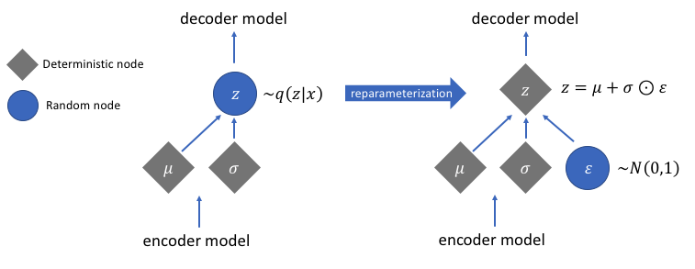
- Conditional VAEs (CVAE)
Conditional Variational Autoencoders (CVAEs) are an advanced form of VAEs that add conditional information to control what the model generates. In a normal VAE, the model learns to generate data in general. In a CVAE, you give the model extra input (like a label or description) to guide what kind of data it should create. For example, if you train a CVAE on handwritten digits and provide the number label (0–9), it can generate a specific digit when asked like “generate a 5.” This makes CVAEs semi-controlled generators, capable of producing class-specific or context-based outputs. In text generation, they can produce sentences with a chosen emotion or style; in images, they can produce objects of a specified type or color. By conditioning on additional data, CVAEs give users control over the generation process while keeping the flexibility of a probabilistic model. They are widely used in image-to-image translation, style transfer, and personalized generation tasks.
- Applications: Image Reconstruction, Anomaly Detection, Text Embeddings
VAEs have a wide range of practical applications in AI and data science. In image reconstruction, they can recreate images with missing or noisy parts by learning the essential patterns behind visual data. In anomaly detection, they learn what “normal” data looks like and can flag inputs that don’t fit that pattern useful in industries like finance, cybersecurity, or manufacturing. VAEs also produce text embeddings, meaning they can represent sentences or documents as numerical vectors that capture their meaning and context. This helps in tasks like document clustering, summarization, and search optimization. In healthcare, VAEs generate synthetic medical images for training models without using sensitive patient data. In creative arts, they help generate new designs, faces, or textures for games and animations. Their flexibility makes them valuable wherever data understanding, compression, and generation are needed.
- Limitations of VAEs and Comparison with GANs
Although VAEs are powerful and stable, they also have some limitations. The main issue is that their generated outputs often look blurry or less detailed compared to results from Generative Adversarial Networks (GANs). This happens because VAEs focus on reconstructing averages of possible outcomes rather than fine-tuning sharp details. GANs, which use an adversarial generator discriminator setup, tend to produce sharper and more realistic results. However, VAEs are much more mathematically grounded, easier to train, and more interpretable. They also have a continuous and smooth latent space, which GANs often lack. While GANs excel in producing realistic imagery, VAEs are preferred for representation learning, anomaly detection, and controlled generation. In fact, many modern models combine the strengths of both creating VAE-GAN hybrids for best results. So, while VAEs may not always create perfect visuals, they remain one of the most elegant and foundational approaches to creative AI.

5. Generative Adversarial Networks (GANs)
- Introduction to GAN Architecture
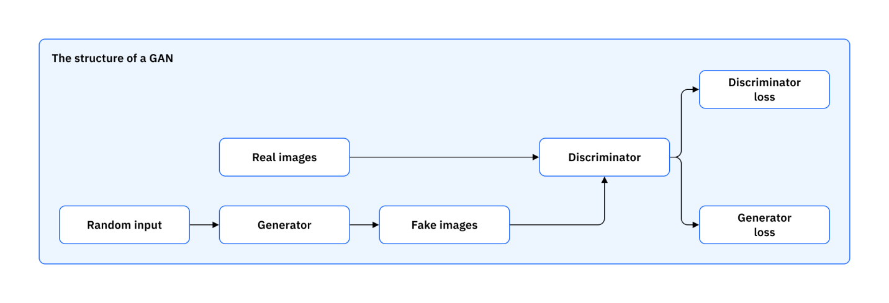
Generative Adversarial Networks, or GANs, are one of the most groundbreaking architectures in modern AI, introduced by Ian Goodfellow in 2014. A GAN is made up of two main neural networks the Generator and the Discriminator which compete against each other in a game-like training process. The Generator’s job is to create new, fake data that looks real (for example, generating realistic human faces). The Discriminator’s job is to detect whether an input is real or fake, acting like a quality inspector. As training progresses, the Generator gets better at fooling the Discriminator, while the Discriminator becomes better at spotting fakes. This continuous competition helps both networks improve simultaneously, leading to highly realistic data generation. GANs can learn to produce high-quality images, videos, and audio from random noise. This architecture introduced a new era of creative artificial intelligence, where machines could generate content nearly indistinguishable from real data.
- Generator vs Discriminator Framework
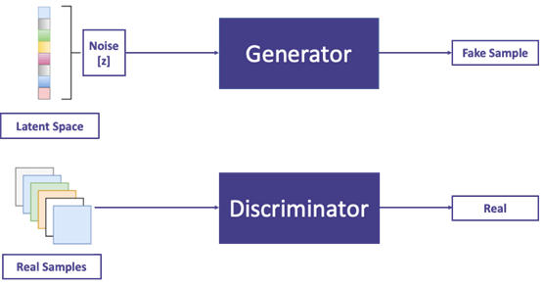
In the GAN framework, the Generator (G) and Discriminator (D) play a two-player zero-sum game. The Generator takes random noise as input and converts it into data that resembles the training dataset such as fake images that look real. The Discriminator receives both real data (from the dataset) and fake data (from the Generator) and tries to correctly identify which is which. If the Discriminator correctly identifies fake data, it improves its ability to detect; if the Generator fools it, the Generator improves. This competition continues until the Discriminator can no longer tell the difference between real and generated samples. In the end, the Generator learns to model the data distribution perfectly, producing incredibly realistic outputs. The key idea is adversarial learning improvement through competition. It’s like an artist (Generator) improving by trying to fool an art critic (Discriminator) who keeps spotting flaws until both reach perfection.
- Loss Function (Minimax Game)
GANs are trained through a minimax game, where one network tries to minimize the loss while the other tries to maximize it. The Discriminator wants to maximize its accuracy — identifying fake data correctly. The Generator wants to minimize its loss by producing outputs that the Discriminator believes are real.
Mathematically, the objective is written as:
Here, D(x) is the probability that the Discriminator thinks a real image is real, and D(G(z)) is the probability it assigns to fake data being real. The Generator aims to make D(G(z)) as close to 1 as possible meaning it wants its fake data to be accepted as genuine.This tug-of-war is what drives GANs to create increasingly realistic and detailed data over time. However, because both networks learn at once, training must be carefully balanced to avoid instability.
- Training Challenges (Mode Collapse, Instability)
Despite their power, GANs are known for being difficult to train. One major issue is Mode Collapse, where the Generator produces limited variations of outputs for example, generating the same type of face over and over. This happens when the Generator finds a small set of “tricks” that consistently fool the Discriminator. Another problem is Training Instability if the Generator or Discriminator learns too fast or too slow, the training can diverge, and both models stop improving. GANs are also sensitive to hyperparameters like learning rate, batch size, and network architecture. Researchers have introduced various improvements, such as gradient penalties and Wasserstein loss, to stabilize GAN training. Despite these challenges, with careful tuning and balanced learning, GANs can achieve outstanding results that outperform many other generative models in realism.
- Types of GANs:
  - DCGAN (Deep Convolutional GAN)
DCGANs use convolutional neural networks (CNNs) in both the Generator and Discriminator to handle image data effectively.They capture spatial hierarchies in images, producing clear and structured visuals. DCGANs were among the first to generate high-quality, detailed images from random noise.
  - WGAN and WGAN-GP
The Wasserstein GAN (WGAN) introduced a new loss function based on the Wasserstein distance, which measures how far the generated data distribution is from the real one. This makes training more stable and helps avoid mode collapse. The WGAN-GP adds a “gradient penalty” for smoother optimization, improving performance further.
  - CycleGAN
CycleGAN is designed for image-to-image translation without needing paired examples. For instance, it can convert photos of horses to zebras or summer scenes to winter ones. It works by training two GANs in a cycle to translate images back and forth between two domains.
  - StyleGAN and StyleGAN2
StyleGAN, developed by NVIDIA, is famous for creating extremely realistic human faces. It introduces “style control,” allowing fine-tuned manipulation of features like age, expression, and background. StyleGAN2 improves stability and detail, achieving photo-realism indistinguishable from real photography.
  - Conditional GAN (CGAN)
Conditional GANs add a condition or label to both Generator and Discriminator. For example, by giving the label “cat,” the model generates only cat images. This allows for controlled and guided generation ideal for targeted content creation.
- Applications: Image Generation, Style Transfer, Super-Resolution
Generative Adversarial Networks (GANs) are widely used in creative, scientific, and industrial fields because of their ability to generate new, realistic data. Their main applications include image generation, style transfer, and super-resolution, among others.
Image Generation:
GANs can create entirely new and realistic images from random noise. For example, models like StyleGAN generate human faces that don’t exist in reality. They’re used in fashion design, film, gaming, and virtual character creation because they can produce lifelike visuals instantly.
Style Transfer:
GANs can combine the content of one image with the artistic style of another — for instance, converting a photo into a painting. CycleGANs even perform image-to-image translation without paired examples, such as turning a sunny photo into a rainy one or transforming horses into zebras. This is used in digital art, advertising, and AR filters.
Super-Resolution:
In this task, GANs improve image clarity and detail, converting low-resolution or blurry images into high-resolution ones. Models like SRGAN can restore old photos, enhance medical scans, or sharpen satellite images. They’re useful in healthcare, security, and multimedia enhancement.
Beyond these, GANs are also used for video creation, 3D modeling, data augmentation, and AI-based art generation. They bring imagination and realism together allowing machines to act as digital artists, designers, and photographers.
- Evaluation Metrics for GANs (FID, IS)
Evaluating GANs is challenging because their goal is to create realistic data, not exact copies. To measure how good the generated data is, two main metrics are used — Inception Score (IS) and Fréchet Inception Distance (FID).
Inception Score (IS):
IS checks the quality and diversity of generated images using a pre-trained image classifier. If the images look clear and belong to distinct categories, the score will be high. A higher IS means the GAN produces realistic and varied outputs. However, IS doesn’t compare generated images to real ones, so it can be misleading if the dataset is biased.
Fréchet Inception Distance (FID):
FID is the most reliable metric today.It compares real and generated images by measuring how close their statistical features are. A lower FID means the generated images are closer to real data in both quality and diversity. FID can detect subtle issues like blur, artifacts, or lack of variety that IS may miss.
Other Metrics:
Researchers sometimes use additional methods like Precision and Recall, Perceptual Path Length (PPL), or even human judgment to evaluate realism. But FID remains the gold standard because it reflects both accuracy and authenticity.
6. Diffusion Models
- Introduction to Diffusion-Based Models
Diffusion Models are one of the most advanced and powerful generative AI techniques today. They work by teaching an AI to generate new data (like images or videos) by learning how to reverse a noise process.In simple terms, they start with pure random noise (like static on a TV) and gradually “denoise” it step by step to produce a clear, meaningful image. This process is inspired by how gases or particles diffuse spreading randomly hence the name diffusion models. They learn the exact pattern of how data turns into noise and then learn to reverse it. Compared to older models like GANs or VAEs, diffusion models are more stable, produce higher quality results, and can create incredibly detailed and realistic visuals. They have quickly become the backbone of text-to-image AI tools such as Stable Diffusion, Midjourney, and DALL·E 3. The beauty of diffusion models is their step-by-step refinement process, which makes generation more controlled and consistent, rather than chaotic or random. This fine-tuned generative process allows them to achieve unmatched realism in AI-generated content.
- Forward and Reverse Diffusion Process
The concept of diffusion involves two main stages the forward process and the reverse process. In the forward diffusion process, noise is gradually added to real data over many small steps until it becomes completely random noise. For example, if you take a clear photo and keep adding tiny amounts of noise, it will eventually turn into pure static. This stage teaches the model how images deteriorate.
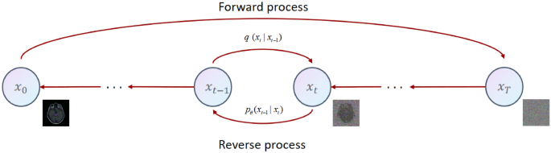
The reverse diffusion process is where the model learns to remove that noise step-by-step, restoring structure and detail to turn noise back into a realistic image. By training on many examples, the model learns the exact way to reverse this destruction process. When generating new data, it starts from random noise and applies the reverse process to create a brand-new, realistic image. This slow, iterative denoising gives diffusion models their famous clarity, detail, and precision each step brings the image closer to perfection.
- Denoising Diffusion Probabilistic Models (DDPM)
Denoising Diffusion Probabilistic Models (DDPMs) are the core mathematical framework behind diffusion models. They were introduced by Ho et al. in 2020, and they define how the forward and reverse diffusion processes are modeled probabilistically. In DDPM, every step of noise addition and removal is treated as a small, controlled probabilistic transition. The model learns to predict and remove noise at each step, effectively “denoising” an image from random static back into a real-looking photo. Training a DDPM requires teaching the model on thousands of clean and noisy image pairs, so it learns the correct denoising patterns. The result is a model capable of generating very realistic and high-resolution images with fine details. However, because DDPMs perform hundreds or even thousands of steps to generate one image, they can be slow during inference. Despite this, their accuracy, stability, and output quality make them one of the most reliable generative AI methods ever created.
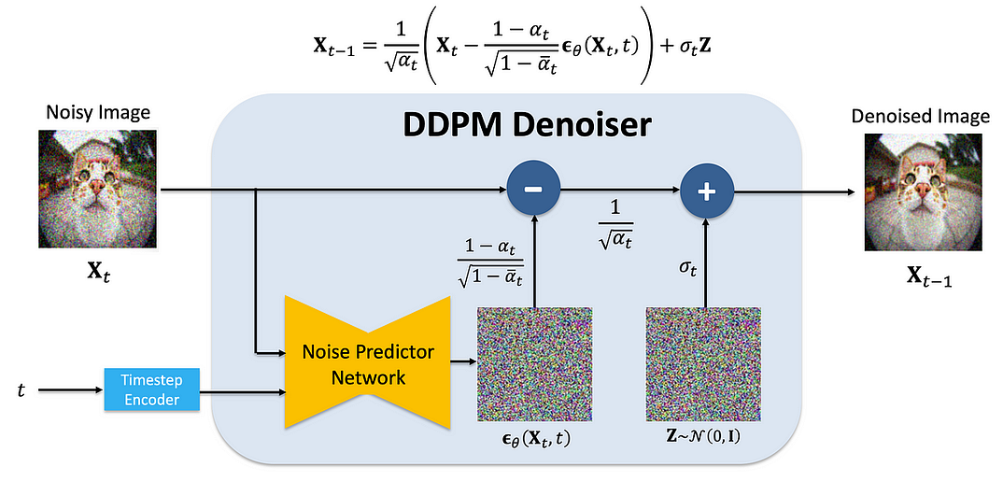
- Denoising Diffusion Implicit Models (DDIM)
Denoising Diffusion Implicit Models (DDIMs) are an improved and faster version of DDPMs. They use a similar diffusion process but allow fewer denoising steps while keeping the quality of the output high. This makes DDIMs much more efficient, reducing the generation time from hundreds of steps to just a few dozen. DDIMs also introduce a level of deterministic control, meaning the same prompt or input can consistently produce the same image, unlike purely random methods. They achieve this by using a slightly different mathematical approach to the reverse process, allowing smoother transitions between noise states. In short, DDIMs preserve the realistic quality of DDPMs but generate results faster and more predictably, making them ideal for real-world applications. This balance between speed and quality is one reason diffusion-based systems like Stable Diffusion and Midjourney are so efficient today.
- Latent Diffusion Models (LDM)
Latent Diffusion Models (LDMs) are an advanced form of diffusion model that make generation faster and less computationally heavy. Instead of applying diffusion directly on large image pixels (which is expensive), LDMs first compress images into a smaller latent space using an autoencoder. This means they don’t denoise full-size images they denoise compressed feature representations. Once the denoising process is complete, the autoencoder decodes the result back into a full-resolution image. This drastically reduces memory usage and speeds up training while maintaining high visual quality. LDMs are the foundation of Stable Diffusion, which can generate 1024×1024 images in seconds using only consumer GPUs. They also make it possible to train large-scale generative models on affordable hardware, democratizing access to AI creativity. In short, LDMs made diffusion models practical, efficient, and scalable for everyone not just research labs.

- Stable Diffusion and ControlNet
Stable Diffusion is one of the most famous implementations of latent diffusion models, developed by Stability AI in 2022. It takes a text prompt as input and generates detailed, realistic images that match the description a process known as text-to-image generation. Stable Diffusion is open-source, allowing developers and artists worldwide to create AI tools, games, and artworks. It uses a neural component called a U-Net for denoising and a CLIP model for understanding text prompts. On top of Stable Diffusion, another model called ControlNet was introduced to add precise control over image generation.ControlNet allows users to guide the output using references such as edge maps, poses, or sketches making the generation more structured and predictable.Together, Stable Diffusion and ControlNet represent the next level of creativity in AI, combining freedom of imagination with fine-grained control over the result.
- Text-to-Image Generation (Prompt-to-Pixel Mapping)
Text-to-image generation is one of the most popular and magical uses of diffusion models. In this process, the model takes a text prompt (like “a cat wearing sunglasses on the beach”) and converts it into an image that visually matches the description. This is achieved through prompt-to-pixel mapping, where the AI first encodes the meaning of the text using a language model like CLIP or GPT. Then, it guides the diffusion process to fill in image pixels that align with the meaning of the prompt. The model repeatedly refines the image through denoising steps until it matches both the text and visual quality standards.This allows users to “paint with words” simply describing what they want and letting AI visualize it.It has revolutionized digital art, design, and content creation, making creative generation accessible to everyone.
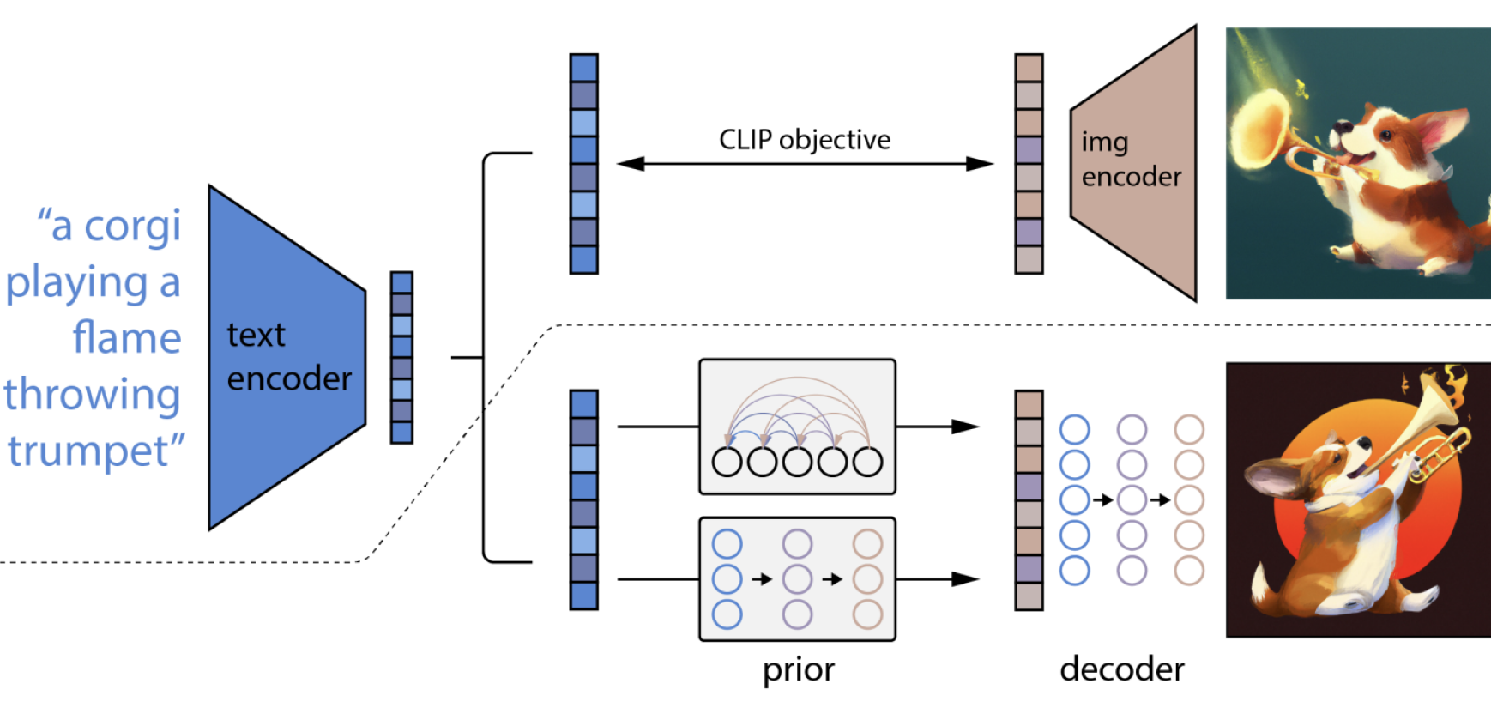
- Applications: Image Synthesis, Video Generation, Art Creation
Diffusion models have become central to AI-based creativity and design. Their ability to generate high-quality, realistic, and creative data has made them one of the most important breakthroughs in modern artificial intelligence. They’ve opened up countless creative and industrial applications, particularly in image synthesis, video generation, and art creation:
Image Synthesis: Generating completely new, realistic, or artistic images from text prompts or sketches. In image synthesis, diffusion models generate new and realistic images from random noise or text prompts. They gradually remove noise step by step to create lifelike visuals that match user descriptions. They’re used in advertising, entertainment, product design, and architecture for fast and imaginative visual creation.
Video Generation: Extending diffusion to time-based data to create short AI-generated video clips or animations.Diffusion-based video generation extends image synthesis over time, creating moving, realistic videos frame by frame. Models like RunwayML Gen-2 and Pika Labs can turn text prompts or static images into short video clips. For example, a user can describe “a dog playing in a park,” and the model generates a full motion sequence.
Art Creation: Empowering digital artists to create surreal or photorealistic artworks in seconds. They are also used in fashion design, architecture visualization, and film concept art.Diffusion models have redefined art by enabling AI-powered creativity. Anyone can create professional-quality artwork simply by typing a description a process known as prompt-based art. Tools like Stable Diffusion and Midjourney let users experiment with style, mood, and detail to create illustrations, concept art, and designs. Artists now use AI as a creative partner combining human imagination with machine precision.
7. Transformer Models and Large Language Models (LLMs)
- Transformer Architecture Recap (Attention Mechanism)
The Transformer architecture is the backbone of modern AI systems, including ChatGPT, Gemini, and Claude. It was introduced by Vaswani et al. in 2017 in the paper “Attention is All You Need.” Transformers revolutionized AI because they can handle long-range dependencies in data (like remembering earlier words in a long paragraph) much better than older models like RNNs or LSTMs. The key innovation in transformers is the Attention Mechanism specifically, Self-Attention. This allows the model to focus on different parts of a sentence simultaneously to understand context. For example, in the sentence “The dog chased the ball because it was fast,” the model learns that “it” refers to “dog,” not “ball.” Self-attention calculates attention weights that decide how much importance each word should give to others. Transformers consist of multiple layers of multi-head attention, feed-forward neural networks, layer normalization, and residual connections. This parallel, non-sequential design makes transformers faster, more accurate, and highly scalable. Because of their efficiency, they’ve become the foundation for almost every major AI model in text, vision, and audio today.
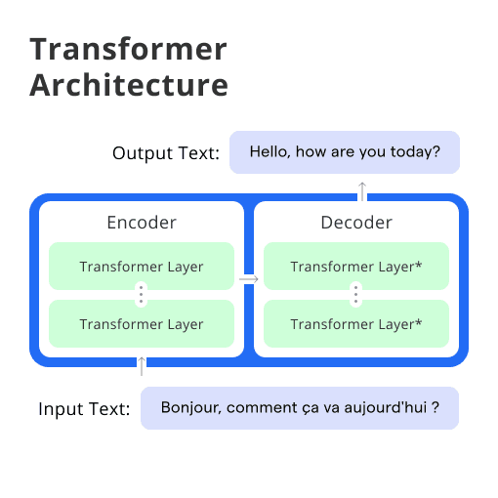
- Decoder-Only and Encoder-Decoder Architectures
Transformers come in two main architectural forms — Encoder–Decoder and Decoder-Only models. An Encoder–Decoder Transformer has two parts:
The Encoder reads and understands the input (like in translation tasks).The Decoder takes this encoded information and generates the output (like translating to another language). Models like T5 (Text-To-Text Transfer Transformer) and Google Gemini use this format because it’s great for sequence-to-sequence tasks such as summarization or translation. On the other hand, Decoder-Only models, like GPT (Generative Pretrained Transformer), use just the decoder part. They read the text input and predict the next word step by step, making them ideal for text generation, conversation, and completion. Decoder-only transformers are faster and more efficient for open-ended generation tasks, while encoder-decoder models are better for structured input-output transformations.
- Pretraining Objectives (Causal LM, Masked LM)
Before being used for tasks, large language models (LLMs) are pretrained on massive text datasets to learn grammar, facts, reasoning, and context. Two main objectives guide this pretraining:
Causal Language Modeling (Causal LM): Used in GPT-type models, it predicts the next word in a sequence. For example: “The cat sat on the ___” → the model predicts “mat.” It reads text in one direction (left to right), learning to generate fluent, natural language.
Masked Language Modeling (Masked LM): Used in models like BERT and RoBERTa. Here, some words are hidden (masked), and the model predicts them using context from both sides. For example: “The [MASK] is blue” → predicts “sky.” This approach helps models understand relationships and meaning rather than just predict words.Causal LMs are better for generation, while Masked LMs are stronger at understanding and classification tasks.
- Popular LLMs: GPT, LLaMA, Claude, Gemini, Mistral, Falcon
There are several leading large language models, each with unique strengths:
GPT (OpenAI): The most famous family, known for ChatGPT. It uses a decoder-only transformer architecture and excels at natural conversation, reasoning, and coding.
LLaMA (Meta AI): An open-source family of efficient models trained for versatility and research accessibility. Used as the base for many customized AIs like Alpaca.
Claude (Anthropic): Focuses on safe and ethical AI behavior, designed for reliability and long-context reasoning.
Gemini (Google DeepMind): A multimodal model that can process text, images, audio, and video simultaneously.
Mistral: A smaller but powerful open-source model optimized for speed, efficiency, and reasoning tasks.
Falcon: Developed by the Technology Innovation Institute, Falcon is one of the most efficient open-weight transformer models for commercial use. Each of these models relies on the same core transformer principles but differs in training data, safety rules, and performance optimization.
- Text Generation and Completion
Text generation is one of the most direct applications of LLMs. These models can take a prompt like a question or sentence fragment and generate a coherent continuation.
For example:
Prompt → “Artificial intelligence will change the world by…”
Generated text → “automating routine work, enhancing creativity, and improving decision-making.”
This happens because the model predicts the most likely next word based on learned probabilities. LLMs can write stories, essays, emails, poems, summaries, and even computer code. They use context windows (the amount of text they can “remember” at once) to maintain flow and coherence. Advanced models like GPT-4 and Gemini can also adapt their tone, language style, and factual accuracy to suit user intent. Thus, text generation is not just about writing it’s about communicating intelligently like a human.
- Tokenization, Context Window, and Embeddings
Tokenization is the process of breaking text into small pieces called tokens. Each token can be a word, a part of a word, or even punctuation. For example, the sentence “I love AI” might become tokens like [I] [love] [AI]. This helps the model handle any kind of text efficiently — even unknown words by splitting them into smaller parts. Once the text is tokenized, each token is converted into a vector of numbers called an embedding.
Embeddings capture the meaning and relationships between words.For example, the embeddings for “king” and “queen” are close to each other because their meanings are related.
This allows the model to understand context, similarity, and relationships in language mathematically.
The context window refers to how much text the model can “remember” and use at one time when generating responses. Smaller models might handle 2,000 tokens (a few paragraphs), while advanced ones like GPT-4 or Gemini can process over 100,000 tokens (dozens of pages). A larger context window means the AI can maintain better understanding across long conversations or documents.
A larger context window allows the AI to understand longer conversations or documents in one go. Together, tokenization, embeddings, and context enable LLMs to read, remember, and generate text meaningfully.They allow AI to turn text into math, math into meaning, and meaning back into clear, natural words.
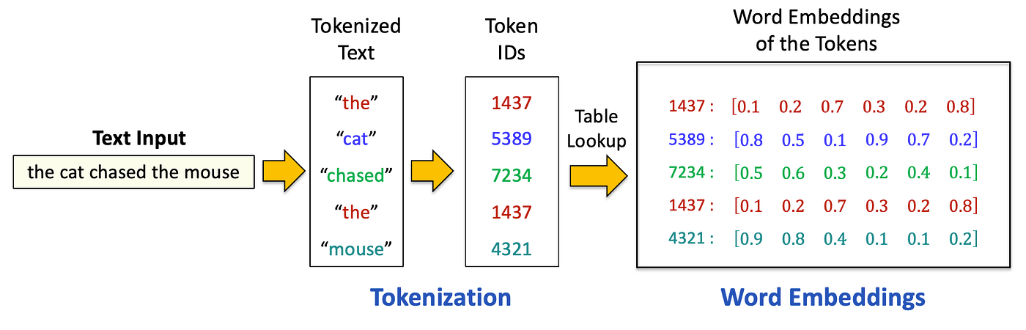
- Fine-Tuning vs Instruction-Tuning vs RLHF
Once pretrained, LLMs can be refined for specific tasks through fine-tuning. After a Large Language Model (LLM) is pretrained on massive text data, it needs to be refined to perform better for real-world use. That’s where fine-tuning, instruction-tuning, and RLHF come in these are the three main ways to improve and align the model’s behavior.
Fine-Tuning:Fine-tuning means training a pretrained model further on a specific dataset or domain to make it expert in that area. For example, fine-tuning ChatGPT on medical texts makes it better for healthcare answers. It adjusts the model’s weights slightly to focus on specialized knowledge or tasks like summarization, translation, or coding.
Instruction-Tuning: Instruction-tuning teaches the model to follow human instructions naturally.
Instead of just predicting the next word, it learns to respond to commands like “Explain this in simple words” or “Write a paragraph about AI.” This step turns a technical model into a helpful assistant that understands user intent and gives structured answers.
RLHF (Reinforcement Learning from Human Feedback): RLHF makes the model more human-like, safe, and polite. The model generates several responses, humans rate them, and the system learns which ones are most accurate, clear, and ethical. It uses reinforcement learning to improve future responses based on that feedback. This process helps reduce harmful or biased outputs and makes AI align better with human values.
- Evaluation Metrics (Perplexity, BLEU, ROUGE)
To measure the quality of text generated by LLMs, researchers use various evaluation metrics.
Perplexity: Measures how well the model predicts a sequence of words. Lower perplexity means the model is more confident and accurate in its predictions. Checks prediction accuracy and fluency.
BLEU (Bilingual Evaluation Understudy): Commonly used in translation tasks, BLEU compares AI-generated text with reference human translations to measure similarity.Measures similarity to human-written text.
ROUGE (Recall-Oriented Understudy for Gisting Evaluation): Measures how much overlap there is between AI-generated summaries and reference summaries used for summarization tasks. Measures quality of summaries and information overlap.
These metrics help evaluate whether the model is fluent, relevant, and semantically accurate.
In addition to these, human evaluation remains important to judge creativity, emotional tone, and coherence things numbers can’t always measure.
8. Multimodal Generative AI
- What Is Multimodal AI?
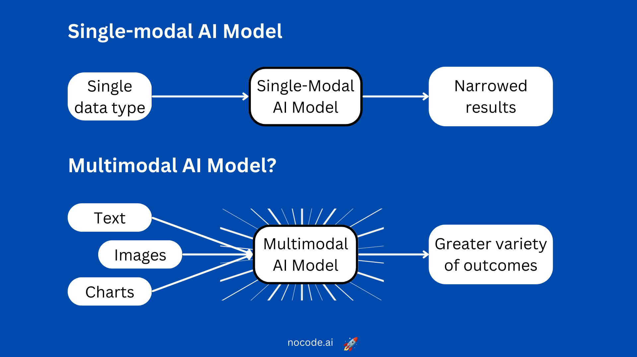
Multimodal AI is a type of artificial intelligence that can understand and generate information across multiple forms of data such as text, images, audio, and video.Unlike older models that handled only one type of input (like text-only or image-only), multimodal AI can connect different senses just like humans see, hear, and speak simultaneously. For example, it can look at an image and describe it in words, or listen to speech and generate matching text or visuals. It combines these abilities to understand context more deeply recognizing not just what something is, but also how it looks, sounds, or feels. Multimodal systems use shared embeddings mathematical representations that merge meaning from all data types into one unified space. This enables AI to “think” about relationships between modalities, like linking the sound of waves to an image of the ocean. Such models power many real-world tools like chatbots that can see images, voice assistants that understand context, or AI art tools that turn words into pictures. In short, multimodal AI allows machines to perceive and create like humans, blending language, vision, and sound into one intelligent system.

- Vision + Language Models (CLIP, BLIP, Flamingo)
Vision-language models connect what AI “sees” with what it “reads.”
CLIP (Contrastive Language–Image Pretraining) by OpenAI trains on image-caption pairs to learn how visuals and words relate. It learns by matching correct image-text pairs and separating mismatched ones building a shared understanding between pictures and sentences. This lets CLIP recognize images, describe them, or even search for them using natural language.
BLIP (Bootstrapped Language–Image Pretraining) improves this process by generating captions automatically and refining understanding through feedback. It can both describe images and answer questions about them, forming a foundation for vision-language interaction.
Flamingo (by DeepMind) combines these ideas with large language models to perform visual question answering — like explaining what’s happening in a photo or recognizing scenes in context. Together, these models help AI understand the visual world using language making applications like image tagging, search, accessibility, and creative art generation possible.
- Image Captioning and Visual Question Answering
Image Captioning means describing what’s inside an image using natural language. The model analyzes visual features like objects, actions, and background and turns them into a meaningful sentence. Example: An image showing a “girl reading a book under a tree” might be captioned as “A young girl enjoying reading outdoors.” This is useful for social media tagging, digital libraries, and accessibility tools for visually impaired users.
Visual Question Answering (VQA) extends this concept users can ask questions about an image, and the AI replies intelligently. For example, given a photo, it can answer: “How many people are in the image?” or “What color is the car?”
VQA combines object recognition, language comprehension, and reasoning. It’s used in surveillance systems, autonomous vehicles, and education apps, where AI needs to describe or analyze visuals contextually. These systems bridge computer vision and natural language processing, enabling machines to “see and speak” at once.
- Audio + Text Models (Whisper, AudioLM, MusicGen)
Audio-text models connect sound and speech with written language.
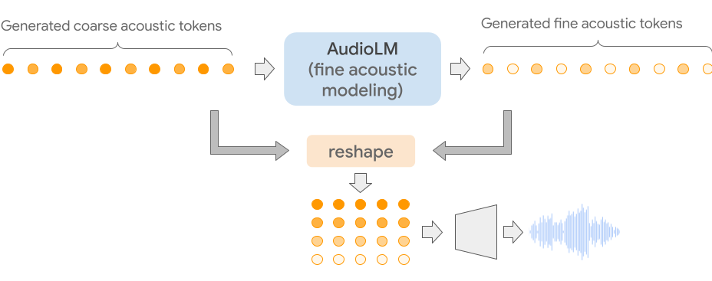
Whisper by OpenAI is a powerful speech-to-text model that can accurately transcribe and translate spoken language into text. It supports multiple languages, accents, and noisy environments making it useful for transcription, subtitling, and accessibility.
AudioLM (by Google) takes things further it doesn’t just recognize sound but can generate it. It learns the patterns of speech, rhythm, and melody, allowing it to continue an audio clip naturally.
MusicGen (by Meta) focuses on creativity it takes a text description like “calm piano music for studying” and generates matching audio. These models are changing industries like music production, podcasting, voice cloning, and AI-powered translation. They allow AI to listen, understand, and create sound — making it capable of both conversation and composition.
- Text-to-Video Models (Sora, RunwayML, Pika)
Text-to-video generation allows AI to create short video clips directly from written descriptions.
The model learns motion, lighting, and scene changes producing smooth, realistic sequences. For example, typing “a waterfall in a forest with sunlight” generates a lifelike video clip of that scene.
Sora (by OpenAI) is a cutting-edge model capable of creating cinematic-quality videos from text prompts.It produces realistic motion, lighting, and perspective often looking like real camera footage.
RunwayML Gen-2 An AI video tool for creators, artists, and filmmakers. It allows users to make videos from text, images, or even existing clips. It’s widely used in advertising, animation, and content design.
Pika Labs specializes in animated storytelling, allowing users to edit camera angles, movements, and effects. These systems use diffusion and transformer-based networks to model time and motion.
Applications include film pre-production, animation, education, marketing, and virtual world creation. This technology makes it possible to “film ideas” turning imagination into video automatically.
- Speech Synthesis and Lip-Sync Models
Speech Synthesis (Text-to-Speech) converts written text into realistic, expressive audio. Modern models generate human-like voices with emotions, accents, and intonation almost indistinguishable from real speech. They’re used in assistive technologies, AI narrators, language learning, and virtual assistants.
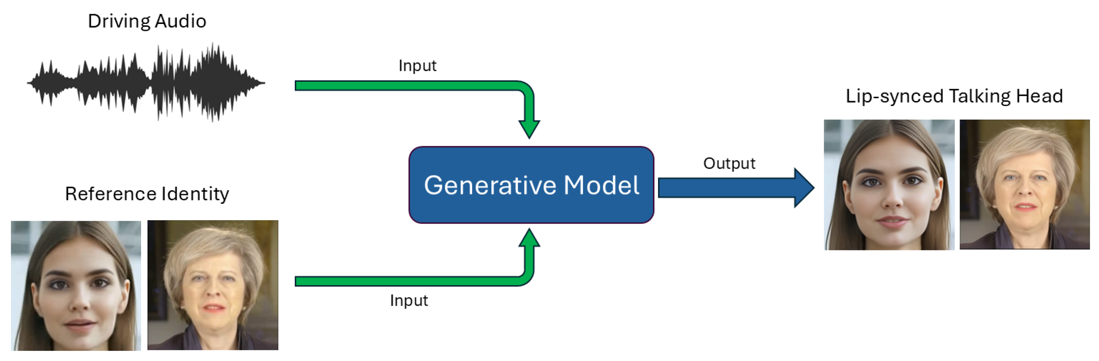
Lip-sync models take it one step further they align a person’s lip movements in a video with speech audio. Models like Wav2Lip and SyncNet analyze mouth shapes and timings to make speech match perfectly with visuals. These are used in movie dubbing, video localization, gaming, and virtual avatars. Together, they make AI communication more human-like, allowing avatars and robots to talk naturally in any language.
- Multimodal Transformers and Embeddings
Multimodal Transformers extend the transformer idea to handle multiple data types simultaneously. They use separate encoders for each input (like image, text, or audio) and merge them into shared embeddings numerical representations that capture common meaning. For instance, the word “dog” and the image of a dog will have embeddings close together in this shared space. This enables the AI to reason across different modalities seamlessly understanding that “a barking sound” relates to “a dog image.” Models like GPT-4V (Vision) and Gemini use multimodal transformers to analyze, describe, and generate content across various formats. This integration allows AI to act as a single system capable of seeing, reading, and reasoning holistically.
- Cross-Modal Alignment and Fusion Techniques
Cross-modal means teaching the AI to correctly match related information across different modalities. Its alignment ensures that information from different modalities corresponds correctly for example, matching a caption to the right image. This is achieved using contrastive learning, where the model learns which text-image pairs match and which don’t.
Once aligned, Fusion Techniques then combine this aligned information to make the AI process all modalities together. fusion techniques merge features from multiple modalities into one output.
There are three common types:
Early Fusion: Combines features from all inputs (like text, audio, video) at the start. Best for tasks where data is tightly connected e.g., lip-sync or speech-video alignment.
Late Fusion: Processes each modality separately and merges their results at the end useful when different data types need individual understanding first.
Hybrid Fusion: Mixes both early and late fusion to balance speed, accuracy, and flexibility.
Together, these techniques help multimodal AI understand relationships across senses, like connecting sounds to visuals or linking captions to scenes.These methods make sure that the AI’s understanding across text, sound, and visuals stays consistent and contextually meaningful.
9. Prompt Engineering and Context Management
- Introduction to Prompt Engineering
Prompt Engineering is the art and science of designing effective inputs (prompts) to guide AI models toward producing accurate, useful, and creative outputs. A prompt is the instruction or query you give to an AI for example, “Explain photosynthesis in simple words” or “Write a story about a robot in space.” Since AI models like ChatGPT and Gemini generate responses based entirely on the input they receive, the quality of the prompt determines the quality of the result. Good prompt engineering helps the model understand the intent, tone, and detail level of your request. It’s not about tricking AI it’s about communicating clearly and strategically. Prompt engineering involves understanding how the model interprets language, context, and structure. For example, vague prompts like “Tell me something about AI” produce generic answers, but specific prompts like “Explain how AI is used in healthcare with two real examples” produce focused, valuable responses.It’s also about structuring information giving background, examples, and constraints in a logical order. In short, prompt engineering is how we “teach” AI in real time turning it into a collaborator, not just a tool. With effective prompts, users can control style, emotion, depth, and even reasoning steps in the AI’s response. It’s used across domains from writing and design to coding, data analysis, and image generation.The better the prompt, the smarter and more aligned the AI output becomes.

- Types of Prompts (Instructional, Chain-of-Thought, Zero/Few-Shot)
Prompt engineering includes different styles of prompting, each suited for specific tasks:
Instructional Prompts:
These are simple, direct commands that tell the AI exactly what to do. Example: “Summarize this paragraph in 3 lines” or “Write a Python function for sorting numbers.” They work best for clear, well-defined goals.
Chain-of-Thought Prompts:
These encourage the AI to show its reasoning step by step before giving an answer. Example: “Explain your reasoning before giving the final answer to this math problem.” This improves accuracy in logic-based or calculation-heavy tasks.
Zero-Shot Prompts:
Here, the AI is given a task without examples it relies on prior knowledge. Example: “Translate this sentence into French.” Useful when tasks are simple or general.
Few-Shot Prompts:
These provide a few examples before asking for a result. Example: showing two examples of polite email replies, then asking the AI to write one more. This helps the model learn the pattern or tone you expect.
- Context Windows and Token Management
Every AI model has a context window, which is the maximum amount of text (in tokens) it can “see” or remember at once. Tokens are chunks of text (words or subwords). For example, “Hello” might be 1 token, and a long sentence may take 10–15 tokens. Older models like GPT-3 had a 2,000-token limit (around 1,500 words), while newer ones like GPT-4 or Gemini can handle 100,000+ tokens, meaning they can process long documents or conversations in one go. Managing tokens is important because when the context window is full, older information gets “forgotten” or truncated. So, context management ensures that only the most relevant data stays within the model’s memory. This includes summarizing long text, referencing key details, or breaking tasks into smaller parts. Developers also use token optimization to make prompts shorter and efficient — for example, replacing unnecessary words with concise phrasing. Good token management helps the AI stay focused, prevents irrelevant answers, and improves processing speed. In short, context windows define the AI’s “attention span,” and smart token management keeps that attention on what matters most.
- Role of System and User Prompts
In conversational AI systems, prompts are divided into roles usually system, user, and sometimes assistant roles.The System Prompt sets the overall personality, tone, and behavior of the AI.It acts as the “rulebook.” For example:“You are a helpful and polite AI assistant that explains complex topics clearly.” This stays hidden from the user but guides the AI’s behavior in every response. The User Prompt is what the person types the actual question or request. For example: “Explain quantum physics in simple words.” The system combines both prompts, applying its general behavior (system) with the user’s specific request. Some systems also include an Assistant Role, which represents previous AI responses in the conversation. This helps maintain continuity and context. Understanding these roles helps you craft better conversations adjusting personality, style, and focus. In practice, prompt engineers often refine both system and user prompts together for smoother, human-like dialogue.
- Techniques for Better Responses:
  - Reframing and Iterative Prompting
Instead of expecting the best result in one go, you can reframe and refine your prompt step by step. For example, if the response is too short, you can ask, “Explain in more detail,” or “Add real-life examples.” This iterative feedback loop helps the model improve continuously.
  - Role Prompting and Style Control
You can assign roles to the AI to change its tone or approach. Example: “Act as a teacher explaining to beginners,” or “Write as a professional journalist.” This gives more control over the voice, tone, and structure of the answer.
  - Prompt Chaining and Memory
Prompt chaining means connecting multiple prompts so the model completes complex, multi-step tasks. For example:
1. Generate a summary of a document.
2. Use that summary to create quiz questions.
3. Format the answers in a table.
Each prompt feeds into the next, forming a logical chain. Memory techniques store previous answers so the model can refer back to them useful for long projects or continuous conversations. These techniques make AI outputs more structured, detailed, and aligned with your goals.
- Prompt Evaluation and Debugging
Just like software, prompts can have “bugs” unclear instructions or conflicting phrasing that cause wrong or vague answers. Prompt evaluation means testing how well a prompt performs across multiple runs and situations. Just like programmers test and fix their code, prompt engineers must test and refine prompts to make sure AI models behave as expected. Prompt Evaluation means checking how well a prompt performs. This involves running the same prompt multiple times and checking:
  - Accuracy — does the AI give the right or expected answer?
  - Consistency — does it repeat the same quality of response each time?
  - Relevance — does it stay on topic or drift away?
  - Completeness — does it cover everything asked in the instruction?
Prompt debugging is the process of fixing prompts making them clearer, more specific, or better structured. For instance, if you ask “Tell me about Java,” the model might confuse the language with the island. Rewriting it as “Explain the Java programming language” resolves the ambiguity. Prompt Debugging means improving prompts when the results are poor. This can be done by:
  - Rephrasing the prompt to make it clearer or more specific.
  - Breaking large tasks into smaller steps.
  - Adding examples or formatting instructions.
  - Using role-based prompts like “You are a teacher…” for tone control.
  - Removing ambiguous or redundant words.
- Prompt Engineering for Text, Image, and Code Models
Prompt engineering differs slightly depending on the model type:
Text Models (like ChatGPT, Claude): Text-based models generate or analyze written content. Good prompts for these models include clear goals, tone, and structure.Example: “Write a motivational paragraph in a poetic tone.”
Image Models (like DALL·E, Midjourney): Image-generation models turn text prompts into pictures. They rely on descriptive, visual language that specifies the style, setting, lighting, and mood. Example: “A realistic painting of a sunrise over the mountains, in warm tones.”
Code Models (like Codex, Code Llama): Code models specialize in programming-related prompts. They need structured, precise instructions since code is logical, not descriptive. Example: “Write a Python function that checks if a number is prime.”
Each domain requires different prompt design text prompts use structure and intent, image prompts use descriptive detail, and code prompts rely on logic and accuracy. Understanding these differences helps prompt engineers get the best from each AI model type.
- Tooling: LangChain, PromptLayer, Guidance, LlamaIndex
As AI projects grow complex, managing and optimizing prompts manually becomes difficult. they help developers automate, track, and scale prompt workflows efficiently. That’s where prompt engineering tools like LangChain, PromptLayer, Guidance, and LlamaIndex come in To manage and automate complex prompting systems, developers use specialized prompt engineering tools:
LangChain: LangChain is one of the most popular frameworks for building applications powered by Large Language Models (LLMs). It allows developers to create prompt chains sequences of prompts where the output of one step becomes the input of another. It also supports memory management, meaning the AI can recall previous interactions within a session. LangChain integrates with external data sources like databases or APIs, making LLMs more dynamic and context-aware. It’s widely used in AI chatbots, document summarizers, and question-answering systems.
PromptLayer: PromptLayer is like a version control system for prompts. It tracks every prompt you send to an AI model and stores the responses. This helps compare how small wording changes affect performance. You can tag, organize, and experiment with prompts easily ideal for debugging or A/B testing. Developers use it to find the “best-performing” prompt variations and monitor how models behave in production.
Guidance: Guidance is a prompt templating tool that lets developers structure complex prompts with logic and conditional rules. It enables you to combine natural language and code for example, creating dynamic prompts that adapt based on user input. Guidance makes it easier to generate consistent, formatted outputs (like tables, summaries, or code blocks). It’s often used in data analysis, content generation, and workflow automation.
LlamaIndex (formerly GPT Index): LlamaIndex helps connect LLMs to external or private data sources. For instance, you can use it to make an AI assistant answer questions from your company’s documents or databases. It builds an index of that data so the AI can search and retrieve relevant information quickly a method known as Retrieval-Augmented Generation (RAG). It’s widely used in enterprise chatbots, research assistants, and data-driven applications.
These tools make prompt workflows organized, testable, and repeatable, bridging the gap between experimentation and production-level AI systems.
10. Fine-Tuning and Adaptation
- What Is Fine-Tuning in Generative AI?
Fine-tuning in Generative AI means retraining a pre-trained model on a smaller, task-specific dataset so it performs better in a particular domain or context. Large AI models (like GPT, LLaMA, or Stable Diffusion) are trained on huge, general datasets containing all kinds of information from books and code to images and conversations. While they understand a lot, they may not always perform perfectly in specialized fields like medical diagnosis, law, or finance. Fine-tuning allows developers to adapt these models to specialized needs without training a completely new model from scratch (which is expensive and time-consuming). For example, a general chatbot can be fine-tuned on legal documents to become a legal assistant, or on medical notes to become a healthcare AI. The process updates only certain parts of the model’s knowledge while keeping the general understanding intact. Fine-tuning can also adjust the model’s tone, personality, or behavior for example, making it sound more formal, polite, or creative. In image generation, fine-tuning teaches models to recognize specific art styles or new objects.
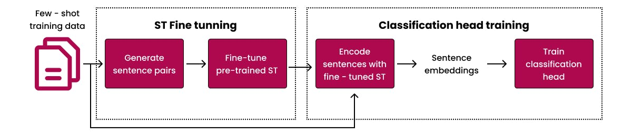
The benefits of fine-tuning include:
  - Improved accuracy and relevance for specific tasks.
  - Faster training and less data compared to building from scratch.
  - Retains general knowledge while learning new patterns.
  - Customizes outputs for brand or domain tone.

- Full Fine-Tuning vs Parameter-Efficient Fine-Tuning (PEFT)
Fine-tuning can be done in two major ways Full Fine-Tuning and Parameter-Efficient Fine-Tuning (PEFT). Both aim to adapt a pre-trained model to new data, but they differ in how much of the model they update.
Full Fine-Tuning:
This approach updates all parameters of the model during training. It’s like re-teaching the entire brain of the AI. While it provides maximum flexibility and performance, it requires huge computational resources (GPUs, memory) and large datasets. For example, fine-tuning a model like GPT-3 fully could take thousands of GPU hours.
Full fine-tuning is ideal when:
  - You have lots of domain-specific data.
  - You want the model to deeply learn new concepts.
  - You can afford high computing costs.
Parameter-Efficient Fine-Tuning (PEFT):
PEFT is a modern approach that updates only a small subset of parameters while keeping the rest frozen. This drastically reduces computational cost and training time. It’s like adding small “adjustment layers” to the model rather than rewriting its entire structure. PEFT methods include LoRA, QLoRA, Prefix Tuning, and Adapter Tuning (explained below).
Advantages of PEFT:
  - Faster and cheaper to train.
  - Less risk of overfitting.
  - Easier to apply on multiple models.
  - Uses less memory and storage.
- Techniques:
Fine-tuning can be done using several specialized techniques that make the process efficient and adaptable.Together, these techniques form the backbone of Parameter-Efficient Fine-Tuning (PEFT) powerful, cost-effective, and scalable.
  - LoRA (Low-Rank Adaptation):
LoRA adds small trainable matrices to the model’s weight layers instead of updating the whole network.These matrices learn the “difference” between the pre-trained knowledge and new domain knowledge. It’s like adding shortcuts for the model to adapt faster. LoRA significantly reduces training costs and storage you can store multiple LoRA adapters for different tasks.
  - QLoRA (Quantized LoRA):
QLoRA improves LoRA further by using quantization, a method that compresses model weights into lower-bit representations (like 4-bit instead of 16-bit). This reduces memory usage dramatically without losing accuracy. It allows fine-tuning very large models (like 65B parameters) even on a single GPU. QLoRA makes fine-tuning affordable and accessible to smaller organizations or research teams.
  - Prefix and Adapter Tuning:
Instead of changing model weights, prefix tuning adds special prompt vectors (prefixes) to the input sequence. The model learns how to adjust its responses based on these prefix instructions. It’s lightweight and works great for text generation or translation tasks.
Adapter Tuning adds small neural modules (“adapters”) between existing layers of the model. Only these adapters are trained while the rest of the model remains frozen. You can plug and unplug adapters for different domains like one for law, another for medicine making models modular and flexible.
- Dataset Preparation for Fine-Tuning
A well-prepared dataset is the foundation of successful fine-tuning.Even a powerful model will perform poorly if trained on low-quality or biased data.Dataset preparation involves cleaning, formatting, and structuring data in a way the model can learn from effectively.Good datasets should be accurate, diverse, and balanced representing all scenarios the model may face. Poor data can cause overfitting (too specialized), hallucinations, or bias in results.
Key steps include:
  - Data Collection: Gather text, images, or code relevant to your domain (e.g., medical records for a healthcare model).
  - Data Cleaning: Remove duplicates, irrelevant info, typos, or sensitive personal data.
  - Formatting: Convert data into model-readable formats (JSON, CSV, or tokenized text).
  - Annotation: Label or structure data if necessary (e.g., intent labels for chatbots).
  - Balancing: Ensure dataset diversity avoid bias toward one style or topic.
  - Splitting: Divide data into training (80%), validation (10%), and testing (10%) sets.
- Model Training Pipeline (Tokenizer → Trainer → Evaluation)
Fine-tuning follows a structured training pipeline with several key stages:
- Tokenizer:
Converts raw text into tokens (numerical representations). Example: “AI is powerful” → [101, 234, 983]. The tokenizer must match the model’s original type, or fine-tuning won’t work properly.
- Trainer:
The trainer handles the learning process feeding data, updating weights, and tracking metrics. It uses frameworks like PyTorch, TensorFlow, or Hugging Face Transformers. Learning rate, batch size, and epochs are tuned for stability.
- Evaluation:
After training, the model’s performance is tested on validation data. Metrics like accuracy, loss, perplexity, and F1 score are used to measure improvement. If performance is unsatisfactory, parameters or datasets are adjusted and retrained.
- Deployment:
Once validated, the fine-tuned model is integrated into an app or API for real-world use. The entire pipeline ensures fine-tuning is systematic, measurable, and repeatable, leading to reliable results.
- Domain Adaptation and Task-Specific Fine-Tuning
Domain Adaptation means adjusting a general AI model to perform better in a specific domain, like healthcare, law, education, or customer support. For instance, GPT can become MedGPT when fine-tuned on medical text, or EduGPT when trained on academic material.
Task-Specific Fine-Tuning focuses on particular use cases within a domain such as sentiment analysis, summarization, translation, or classification.
Example: A customer service chatbot fine-tuned to respond only with polite, brand-specific answers.
Both types make models smarter and more relevant. They improve accuracy, tone, and reliability while maintaining general knowledge. However, domain adaptation must be carefully done too much specialization may cause the model to “forget” general skills (a problem known as catastrophic forgetting). Balancing general and specific knowledge is key.
- Evaluation and Validation of Fine-Tuned Models
After fine-tuning, the model must be evaluated thoroughly to ensure it meets expectations. Evaluation checks how well the model performs on unseen data, while validation ensures it behaves ethically and consistently.
Metrics depend on the task:
  - Text models: Use perplexity, BLEU, ROUGE, or accuracy.
  - Image models: Use FID (Fréchet Inception Distance) or IS (Inception Score).
  - Code models: Evaluate based on execution success or test cases passed.
Human evaluation is also important experts assess whether the output is meaningful, factual, and unbiased. For example, in a medical model, doctors might check if generated summaries are clinically accurate. Once validated, the model is ready for real-world deployment. Continuous monitoring ensures the model remains accurate as data evolves.
Validation also includes testing for:
  - Bias or discrimination in responses.
  - Overfitting — the model memorizing data instead of generalizing.
  - Ethical compliance — ensuring no harmful or private information is produced.
11. Retrieval-Augmented Generation (RAG)
- What Is RAG and Why It Matters?
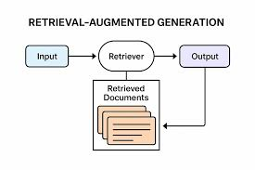
Retrieval-Augmented Generation (RAG) is a powerful AI framework that combines two abilities retrieving real-world information and generating intelligent responses to make AI models more accurate, factual, and useful. Traditional Large Language Models (LLMs) like GPT are trained on massive datasets, but their knowledge is static meaning it stops at the time of training. They can’t access new data or verify facts after deployment. RAG solves this limitation by allowing AI to fetch relevant, up-to-date information from external sources (like databases, documents, or the web) before generating an answer. So instead of “guessing” from memory, the model retrieves supporting content and then uses it to generate accurate, evidence-based responses. RAG transforms AI from a “general knowledge machine” into a real-time, knowledge-aware system that can read, reason, and respond like an intelligent assistant with a live database.
Example:
If you ask, “What are the latest iPhone 16 features?” a normal LLM might be outdated. But a RAG model retrieves the latest Apple info from a document or website and generates a factual summary.
RAG matters because it brings three main benefits:
1. Accuracy: Uses real data instead of relying on memory.
2. Transparency: You can trace where the answer came from.
3. Efficiency: Only retrieves what’s relevant, reducing token cost.
- Architecture: Retriever + Generator
The RAG architecture has two main components the Retriever and the Generator that work together like a research assistant and a writer. The Retriever + Generator pipeline ensures that outputs are factual, relevant, and grounded in evidence. Sometimes, an optional Reranker layer reorders retrieved documents to improve quality before generation. This architecture forms the foundation of AI assistants, knowledge chatbots, and enterprise search systems that can answer from private or real-time data.
Retriever:
This part searches through large collections of text (like documents, PDFs, or knowledge bases) to find the most relevant pieces of information related to the query. It doesn’t understand meaning like humans but uses vector embeddings (numerical representations) to measure how similar two pieces of text are. The Retriever’s goal is to fetch the most useful context for the Generator.
Generator:
Once the Retriever provides the context, the Generator (an LLM like GPT or LLaMA) reads it and creates a natural, coherent answer using that information. It merges reasoning (from the model’s brain) with facts (from the retrieved data).
For example, if a user asks: “Explain the benefits of solar energy,”
→ The Retriever searches for the best articles about solar energy.
→ The Generator then summarizes them into a natural paragraph.
- Vector Databases (Pinecone, Chroma, FAISS, Milvus)
In RAG, the Retriever needs a fast and intelligent way to search for semantically similar information not just keywords. That’s why it uses Vector Databases, which store text in the form of embeddings (vectors) numerical representations of meaning. Popular vector databases include:
Pinecone: A managed cloud-based vector database that provides high-speed semantic search, filtering, and scalability. It’s simple to integrate and used widely in production-level RAG systems.
Chroma: An open-source vector store popular in research and prototyping. It’s lightweight, easy to use with LangChain, and perfect for small projects or local setups.
FAISS (Facebook AI Similarity Search): Developed by Meta, it’s a highly efficient library for nearest-neighbor search in large vector spaces. It’s optimized for speed and supports billions of embeddings.
Milvus: A scalable, open-source database designed for AI and machine learning workloads. It supports distributed storage and advanced vector indexing for huge datasets.
These databases allow the Retriever to quickly find semantically related information, not just exact matches meaning it can understand that “doctor” and “physician” are similar. Without vector databases, RAG systems wouldn’t be able to efficiently handle massive document collections or perform intelligent retrieval in real time.
- Embedding Models (OpenAI, Cohere, Hugging Face)
To store and search information in vector databases, we need to convert text into embeddings mathematical representations of meaning. This is done using Embedding Models. Embedding models read text and output a list of numbers (vectors) that represent its meaning in a high-dimensional space. Texts with similar meanings have embeddings that are closer together in that space.These embeddings are what make semantic search possible allowing the Retriever to find “meaning-related” content rather than keyword matches.
Popular embedding models include:
OpenAI Embeddings (liketext-embedding-3-large): These models are highly accurate and optimized for large-scale RAG applications. They capture deep semantic meaning across multiple languages and contexts. Used widely in ChatGPT-based retrieval systems and document search.
Cohere Embeddings: Known for excellent multilingual performance and contextual similarity.
Cohere models excel in handling sentence-level embeddings and document understanding tasks.
Hugging Face Models (like Sentence-BERT or InstructorXL): Open-source options that allow developers to fine-tune embeddings for specific tasks or domains. For example, legal or medical embedding models trained on specialized text corpora.
For example, the question “What are symptoms of flu?” retrieves text about “fever, cough, fatigue” even if the exact word “symptom” isn’t used. Good embeddings lead to accurate retrieval, which directly improves RAG performance.
- Chunking and Context Retrieval Strategies
When dealing with large documents or knowledge bases, feeding the entire text to an AI is impossible it would exceed the model’s context window. That’s why RAG uses chunking splitting long text into smaller, logical pieces that can be efficiently retrieved. Each chunk is like a “mini paragraph” that represents one idea. When a user asks a question, the Retriever compares the query’s embedding with all chunk embeddings to find the best matches.
Common strategies include:
Fixed-size chunks: Splits text into chunks of equal token length (e.g., 500–1,000 tokens).It’s simple and consistent but may break ideas mid-sentence.
Semantic chunks: Split based on meaning (like headings or topic changes).Uses sentence or paragraph boundaries so each chunk represents a complete thought. It’s more meaningful but computationally heavier.
Overlapping chunks: Adds small overlaps (like 50 tokens) between chunks so that important context isn’t lost between sections.
Once the Retriever identifies relevant chunks, it passes them to the Generator. This ensures the model doesn’t waste memory on irrelevant details but still has enough information to give a complete answer. Choosing the right chunk size is crucial too small, and the model loses context; too large, and it wastes tokens. Optimized chunking leads to faster, more accurate retrievals and better final answers.
- Query Rewriting and Reranking
In real-world conversations, users don’t always ask perfect questions. Queries can be short, vague, or ambiguous for example: “Tell me about Tesla.” This could refer to Tesla the inventor or Tesla the car company.
That’s where query rewriting comes in. It’s the process of improving or expanding the user’s query before searching the database. Using an LLM, the system rewrites the query to be clearer and more specific e.g., “Give me recent information about Tesla, the electric vehicle company, including latest models.” This ensures the Retriever fetches relevant and accurate results.
Once documents are retrieved, reranking happens. Not all retrieved results are equally useful so the system reorders them based on how relevant they are to the query. Reranking can use AI scoring models (like BERT-based similarity scorers) that assign higher scores to more relevant chunks.This layered process reduces confusion, eliminates noise, and gives more factual and well-contextualized answers.
The Process:
1. User query → AI rewrites it into a clearer version.
2. Retriever → Fetches top N relevant chunks.
3. Reranker → Reorders chunks by quality and relevance.
4. Generator → Uses top chunks to create the final answer.
- Evaluation of RAG Systems
Evaluating a RAG system means checking both how well it retrieves and how well it generates. It’s not just about how natural the language sounds it’s about accuracy, grounding, and efficiency. RAG systems are also tested for latency (speed), context handling, and robustness how they perform when queries are complex or phrased differently.
Key Evaluation Metrics:
  - Retrieval Evaluation:
Recall@k: Measures if the correct document appears in the top k results.
Precision: Checks how many retrieved documents are actually relevant.
Mean Reciprocal Rank (MRR): Measures how high the correct result appears in rankings.
  - Generation Evaluation:
BLEU & ROUGE: Compare generated responses with reference (human-written) answers.
Factual Consistency: Ensures that generated text matches real retrieved data.
Faithfulness: Checks that the AI doesn’t “hallucinate” or invent facts.
  - Human Evaluation:
Experts or users rate answers based on clarity, accuracy, coherence, and usefulness. This is important because metrics alone can’t always judge creativity or reasoning.
- Real-World Applications: Chatbots, Search Engines, Assistants
RAG has become the backbone of many real-world AI systems because it combines intelligence with real-time knowledge.RAG brings real-time intelligence to generative AI enabling it to think, search, and reason based on both memory and data.
  - Chatbots:
Enterprise and customer support bots use RAG to answer from internal documents or FAQs. Example:A banking chatbot can retrieve answers from policy files or transaction guides instantly.
  - Search Engines:
RAG improves search by generating summarized, conversational answers rather than just showing links. For example, Perplexity AI and Bing Copilot use RAG to deliver context-based answers.
  - AI Assistants:
Assistants like ChatGPT (with retrieval plugins) or Gemini Pro use RAG to access the latest data or user files. They combine internal intelligence with external document knowledge.
  - Healthcare and Legal Systems:
Fine-tuned RAG models assist doctors or lawyers by retrieving verified information from specialized knowledge bases.
  - Business Applications:
Organizations use RAG-powered tools for document summarization, internal search, and research assistance.

12. Generative AI for Code
- Introduction to Code Generation
Code Generation is a process where AI models automatically write computer programs or code based on human instructions given in natural language. Instead of typing every line manually, developers can simply describe what they want and the AI writes the code for them.Code generation is made possible by Large Language Models (LLMs) trained on billions of lines of open-source code from platforms like GitHub, Stack Overflow, and documentation sites. These models learn programming languages (Python, Java, C++, JavaScript, etc.) the same way they learn human languages by predicting the next token (word or symbol) based on context. For example: A user says, “Write a Python function to calculate factorial,” and the AI produces the exact code instantly.
The AI understands logic, syntax, and problem structure, allowing it to:
  - Write functions, scripts, or full programs from text prompts.
  - Detect and fix bugs automatically.
  - Suggest code completions while typing.
  - Explain or document existing code.
Generative AI for code saves developers enormous time and effort. It helps students learn programming faster, improves productivity in companies, and even reduces human error. Some systems can even read natural language project requirements and convert them into complete, executable code. They are used in software development, data analysis, automation, and machine learning projects. code generation bridges the gap between human intent and machine logic turning plain English into powerful code that runs perfectly. It represents a new era where humans guide, and AI builds faster, safer, and smarter.
- Code Models: Codex, Copilot, StarCoder, CodeLlama
Generative AI for coding is powered by specialized models trained specifically on programming datasets.All these models combine understanding of language and logic to generate clean, readable, and efficient code. They are transforming the world of software development making coding faster, easier, and more collaborative. These models can write, fix, and even reason about code. Let’s understand some of the most popular ones:
  - OpenAI Codex:
Codex, developed by OpenAI, is the model behind GitHub Copilot. It understands both natural language and programming languages. Codex can translate English instructions into executable code, support more than a dozen languages, and even generate APIs or full apps. It’s fine-tuned from GPT-3 and designed for developer workflows from writing SQL queries to building websites.
  - GitHub Copilot:
Copilot is an AI-powered coding assistant integrated directly into code editors like VS Code and JetBrains. It auto-completes lines, writes comments, and suggests entire functions. It uses Codex and context from your current file to predict what you’re trying to do. For instance, if you start typing a loop, Copilot can finish it and add proper variable names automatically.
  - StarCoder (by Hugging Face & ServiceNow):
StarCoder is an open-source model trained on massive code datasets (The Stack). It supports multiple programming languages and is ideal for self-hosted AI development environments. It focuses on transparency and open access, allowing companies to customize it for their internal projects.
  - Code Llama (by Meta):
Code Llama is based on LLaMA 2 and is optimized for coding and reasoning tasks. It can handle natural language-to-code translation, debugging, and explanations. It supports Python, C++, JavaScript, and can even interpret pseudo-code.
- Prompt Engineering for Coding Tasks
Prompt Engineering plays a crucial role in code generation. It means crafting the right instructions so the AI understands exactly what code to produce. Since coding tasks require precision, the prompt must be clear, structured, and complete.
A good coding prompt includes:
1.Task Definition: What do you want the code to do? (e.g., “Write a Python function to find the largest number in a list.”)
2. Input/Output Example: Give sample data and expected results.
3.Constraints: Define what tools or rules to follow (e.g., “Use recursion only.”).
4. Language/Style: Specify the programming language and format.
Example of a clear prompt: “Write a Python function called ‘is_palindrome’ that checks if a string reads the same backward. Include an example call and output.” Chain-of-Thought prompting can be used to make the model show reasoning steps helpful for debugging or learning. Few-shot prompting adds 2–3 example problems and solutions before the real question to improve accuracy. Developers also use role prompting to set behavior: “You are an expert Python developer. Write optimized and readable code.”Good prompts ensure outputs are syntactically correct, logically sound, and easily understandable.
- Natural Language to Code Translation
One of the most exciting uses of generative AI is Natural Language to Code Translation converting plain English instructions directly into executable code.Natural language-to-code translation turns programming into conversation, making software development faster, easier, and more inclusive for everyone.
For example: “Create a JavaScript function to add two numbers.”
AI generates: function add(a, b) {
return a + b; }
This is possible because models like Codex and Code Llama understand both human language and programming syntax.They identify intent (“add two numbers”) and translate it into structured logic that fits the programming language. This ability makes coding accessible to non-programmers anyone can describe what they want and get working code instantly. It also speeds up software creation, testing, and prototyping for professionals. In more advanced use cases, natural language prompts can build full applications generating front-end (HTML/CSS), back-end (Python, Node.js), and database queries (SQL). AI also handles API generation, data pipelines, and machine learning scripts from simple text requests.
For example:“Write a Python script that reads a CSV file and plots a bar chart.” The AI can output complete code using libraries like pandas and matplotlib.
- Code Explanation and Refactoring
Beyond generating code, AI models are also skilled at understanding and improving existing code through explanation and refactoring. AI acts like a code reviewer and teacher explaining logic in simple language and refining structure to make code clean, readable, and efficient.
Code Explanation:
AI can read code and explain it in plain English, making it easier for beginners or teams reviewing legacy code.
For example: def factorial(n):
return 1 if n == 0 else n * factorial(n-1)
AI might explain:
“This function calculates the factorial of a number using recursion it multiplies the number by the factorial of one less until it reaches zero.”This helps developers quickly understand code logic, especially when dealing with large or inherited projects.
Refactoring:
AI can also improve or clean up code without changing its behavior.It removes redundancy, improves readability, and optimizes performance.For instance, converting long if-else statements into switch cases, renaming unclear variables, or simplifying loops. AI refactoring tools can even detect security issues or inefficient patterns. Models like GitHub Copilot, Code Llama, and ChatGPT can automatically suggest improved code structures.
- AI in Software Testing and Documentation
AI has become an incredible ally in software testing and documentation two tasks that are often time-consuming but crucial for quality assurance.AI automates testing and documentation, ensuring code is well-tested, bug-free, and properly explained, improving both quality and team productivity.
AI in Testing:
AI models can automatically generate unit tests, integration tests, and test cases based on your existing code. For example, given a function, it can create multiple input-output tests to check all edge cases.It can simulate user behavior, detect logical bugs, and even suggest test coverage improvements.Some tools use reinforcement learning to identify weak points in code areas that fail under certain conditions.
AI in Documentation:
Writing documentation is often neglected, but AI can generate it automatically. It reads your code, identifies functions, parameters, and outputs, and then produces structured documentation with examples. It can also generate docstrings, API references, and README files in Markdown. AI-generated documentation helps teams understand and maintain software easily. It also assists new developers in learning projects faster.
- Multi-Agent Code Generation (AutoGPT, CrewAI, SWE-Agent)
Multi-Agent Code Generation is an advanced and intelligent approach in Generative AI where multiple AI agents work together like a team of software engineers to design, write, test, debug, and improve code automatically. Each “agent” focuses on one specific task, communicates with the others, and collaborates to complete the full software project just like a human development team.This approach is inspired by real-world teamwork.
How Multi-Agent Code Generation Works The system usually consists of several coordinated AI agents such as:
  - Planner Agent: Understands the user’s main request, breaks it into smaller subtasks, and decides what needs to be built first.
  - Coder Agent: Writes the actual code for each subtask using a generative code model (like Code Llama or Codex).
  - Tester Agent: Runs the code, checks for bugs or errors, and verifies if the output is correct.
  - Reviewer Agent: Reviews the code quality, improves structure, and adds documentation or comments.
  - Coordinator Agent: Manages the communication among all agents, ensuring that all tasks are completed in the correct order.
Key Examples of Multi-Agent Systems
- AutoGPT: One of the first multi-agent AI frameworks built on top of GPT models. AutoGPT can plan and execute long-term coding projects without human help. It creates tasks, searches for data online, writes and tests code, and refines its output automatically. Example: You can ask AutoGPT to “build a calculator app,” and it will plan steps, write the code, test it, and show you the final program.
- CrewAI: A framework designed to coordinate multiple specialized AI agents working together. Each agent can be assigned a “role” (like data scientist, front-end developer, or tester). CrewAI manages how these agents share information and complete a project collaboratively. It’s often used for research, automation pipelines, and enterprise-level AI workflows.
- SWE-Agent (Software Engineer Agent): A cutting-edge system developed to act like a real autonomous software engineer. SWE-Agent can read issue tickets from GitHub, analyze them, write fixes, commit code, and test it. It performs entire software maintenance cycles without human input — coding, debugging, and documentation. It uses reasoning, feedback loops, and memory to continuously improve with each project.
13. Generative AI Frameworks and Tools
- TensorFlow and PyTorch for Generative Modeling
TensorFlow :
TensorFlow is an open-source deep learning platform designed for large-scale machine learning tasks. It provides a flexible ecosystem with tools like Keras for easier model building and TensorBoard for visualization. TensorFlow excels in production deployment, meaning models trained in TensorFlow can easily run on cloud servers, mobile devices, or web apps. It’s widely used for image generation, style transfer, and natural language processing. TensorFlow also supports TensorFlow Extended (TFX) for end-to-end ML pipelines from data preprocessing to model serving. Its eager execution mode helps in debugging and experimentation for generative architectures.
PyTorch :
PyTorch is highly popular among researchers and developers because of its dynamic computation graph — it executes operations immediately, making debugging and testing easier. It’s the go-to choice for developing cutting-edge Generative AI models like GANs (Generative Adversarial Networks), VAEs (Variational Autoencoders), and Diffusion Models (like Stable Diffusion). PyTorch’s torch.nn and torchvision libraries simplify building complex architectures for image, text, and sound generation. It integrates smoothly with tools like Hugging Face, Weights & Biases, and Transformers, making it ideal for research and production.
- Hugging Face Transformers and Diffusers
Hugging Face is one of the most important ecosystems in Generative AI, offering ready-to-use tools, pre-trained models, and APIs for text, image, audio, and code generation.Hugging Face simplifies Generative AI development by offering state-of-the-art models, tools, and datasets empowering everyone from beginners to experts to build creative AI applications quickly.
Transformers Library:
The Transformers library provides thousands of pre-trained models for natural language processing and generation tasks. It includes models like GPT, BERT, T5, BART, LLaMA, and Falcon, all accessible in a few lines of Python code. It allows developers to perform text classification, translation, summarization, question-answering, and chat generation effortlessly. The library supports PyTorch, TensorFlow, and JAX, making it extremely flexible. Users can fine-tune any model with their own dataset using simple APIs enabling custom chatbots or specialized text generators.
Diffusers Library:
The Diffusers library focuses on image and video generation using Diffusion Models, such as Stable Diffusion and DDPMs. It offers plug-and-play pipelines for text-to-image generation, image inpainting, super-resolution, and style transfer. With just a few lines of code, users can generate realistic images from natural language prompts. Hugging Face also provides Spaces, a platform to deploy and share AI apps interactively (using tools like Gradio). It fosters an open-source AI community, where developers and researchers can share and reuse models freely.
- OpenAI API (GPT, DALL·E, Whisper)
OpenAI’s API provides access to some of the most advanced Generative AI models in the world, enabling developers to integrate powerful AI capabilities into their applications easily.The OpenAI API integrates seamlessly with Python, JavaScript, and web platforms. Developers can build AI-powered apps without managing heavy infrastructure or training models from scratch.
  - GPT (Generative Pre-trained Transformer):
The GPT family (GPT-3, GPT-4, GPT-5) powers text generation, chatbots, and creative writing tasks. Developers can use the OpenAI API to generate content, summarize text, translate languages, or write code. It understands context and tone, making it perfect for conversational AI, tutoring systems, and business assistants.
  - DALL·E:
DALL·E is OpenAI’s text-to-image generation model, capable of creating high-quality, realistic, or artistic images from text descriptions. For example, the prompt “a cat sitting on a futuristic chair” can produce multiple unique visuals instantly. It supports inpainting (editing images) and variations (creating stylistic versions of the same concept).
  - Whisper:
Whisper is OpenAI’s speech recognition model for audio-to-text transcription and translation.It supports multiple languages and can generate subtitles, transcripts, or translated audio content accurately.
- Stability AI and ComfyUI Workflows
Stability AI is the company behind the famous Stable Diffusion one of the most powerful open-source text-to-image models.It allows anyone to generate high-quality, realistic images from text descriptions with full creative control.These tools together form a creative powerhouse for visual generation from text prompts to professional art, videos, and 3D textures.
Stable Diffusion:
Unlike closed models like DALL·E, Stable Diffusion is fully open-source. Developers can download, modify, and train their own image models. It uses Latent Diffusion Models (LDMs) that generate images efficiently in compressed space making it faster and more resource-friendly. It’s widely used for art, game design, animation, and advertising.
ComfyUI:
ComfyUI is a visual workflow interface for Stable Diffusion. It allows users to design AI image pipelines using drag-and-drop nodes instead of writing code. Each node represents a function like text input, diffusion step, style filter, or image output connected visually to define the workflow. ComfyUI supports custom models, controlnets, and LoRA fine-tuning, giving artists and developers extreme flexibility.
- LangChain and LlamaIndex for LLM Applications
LangChain and LlamaIndex are frameworks designed to build applications powered by Large Language Models (LLMs) like GPT or LLaMA. They help connect AI models with external data, memory, and logic workflows. Together, LangChain and LlamaIndex form the foundation for real-world LLM applications that can think, reason, and use external knowledge intelligently.
LangChain:
LangChain enables prompt chaining, where the output of one prompt feeds into another creating multi-step reasoning pipelines. It allows developers to integrate LLMs with APIs, databases, or user input dynamically.It also supports memory management, meaning the AI can remember previous parts of a conversation for continuity. LangChain makes it easy to build chatbots, summarization tools, and intelligent assistants that interact with live data. It also connects with vector databases (like Pinecone and Chroma) for retrieval-augmented generation (RAG).
LlamaIndex (formerly GPT Index):
LlamaIndex helps LLMs use private or enterprise data safely and efficiently. It builds indexes from documents, PDFs, or databases that the AI can search when answering questions. This lets companies create custom chatbots that answer from their own knowledge sources — such as manuals or policies.
- Gradio and Streamlit for App Deployment
Gradio and Streamlit are frameworks that make it easy to deploy Generative AI models as web applications without needing advanced web development skills.Both tools are widely used to present and test AI models for example, showing image generation, chatbot interactions, or code generation live in a browser.
Gradio:
Gradio provides a simple interface builder for AI models. You can wrap your AI function (like text, image, or audio generation) in a few lines of Python and instantly get an interactive web app. It supports sliders, buttons, text boxes, and image uploaders, making testing and sharing models easy. Hugging Face Spaces uses Gradio to let users demo AI apps online for free.
Streamlit:
Streamlit focuses on data-driven and AI-based web apps with elegant dashboards. It allows developers to turn Python scripts into interactive apps for model demos, visualizations, and analytics. Streamlit supports components like charts, forms, and file uploads, making it perfect for data scientists.
- ONNX and TensorRT for Model Optimization
When deploying AI models, speed and efficiency are critical. That’s where ONNX and TensorRT come in they optimize models to run faster on different hardware.ONNX ensures portability, while TensorRT ensures performance they make AI models faster, smaller, and ready for production.
ONNX (Open Neural Network Exchange):
ONNX is an open standard that allows models trained in one framework (like TensorFlow or PyTorch) to be converted and run anywhere. It enables interoperability between AI platforms, reducing dependency on specific tools. ONNX simplifies deployment on various devices servers, mobile phones, or IoT systems.
TensorRT (by NVIDIA):
TensorRT is a high-performance inference optimizer for NVIDIA GPUs. It takes trained AI models and optimizes them for maximum speed and minimal memory use. TensorRT uses techniques like precision calibration (FP16/INT8) to improve execution without losing accuracy. It’s commonly used in real-time Generative AI, such as image or video generation, where speed is essential.
- Weights & Biases for Experiment Tracking
Weights & Biases (W&B) is a powerful tool for tracking, visualizing, and managing AI experiments.It’s like a dashboard that records every training run — showing metrics, parameters, and results in real-time.
Developers use W&B to:
  - Compare different models or architectures.
  - Visualize loss curves, accuracy graphs, or FID scores for generative models.
  - Log hyperparameters and track how they affect results.
  - Collaborate with team members by sharing dashboards.
It integrates seamlessly with TensorFlow, PyTorch, Hugging Face, and Keras. For Generative AI, it helps visualize image outputs, monitor training progress, and analyze generation quality. Teams use it to identify which training runs performed best and why. Weights & Biases acts as the control center for AI experiments improving organization, reproducibility, and collaboration throughout the Generative AI development cycle.

14. Evaluation and Metrics in Generative AI
- Qualitative vs Quantitative Evaluation
Evaluating Generative AI models means checking how good, accurate, and realistic their outputs are. There are two main evaluation types: Qualitative and Quantitative, both equally important but serving different purposes. Quantitative metrics ensure consistency and scalability, while qualitative evaluation ensures human-like quality and acceptability.
Quantitative Evaluation:
This method uses numerical metrics or scores to objectively measure performance. It’s based on predefined formulas and datasets for example, BLEU for translation, FID for image generation, or perplexity for language fluency. Quantitative evaluation is fast, repeatable, and comparable across models. It helps in benchmarking models statistically, ensuring that the new model performs better than the previous one. However, it often misses subtle human factors like creativity, emotion, or relevance.
Qualitative Evaluation:
This approach focuses on human judgment analyzing how natural, meaningful, or appealing the output feels to users.For example, humans may rate AI-generated essays based on clarity, grammar, or storytelling. For images, evaluators may check aesthetics, realism, or emotional appeal. It captures subjective qualities that numbers can’t measure.
- Metrics: BLEU, ROUGE, METEOR, FID, IS, CLIPScore
Different types of Generative AI models require different metrics to measure quality text models, image models, and multimodal models all have specialized tools.
Text Generation Metrics:
  - BLEU (Bilingual Evaluation Understudy):
Used for text generation and machine translation. It compares the AI’s output to human-written reference text by matching overlapping words and phrases (n-grams). Higher BLEU means closer to human writing. Limitations: It doesn’t measure meaning, only word overlap.
  - ROUGE (Recall-Oriented Understudy for Gisting Evaluation):
Used mainly for summarization tasks. It measures how much of the reference summary’s words appear in the AI summary. High ROUGE = captures most important ideas.
  - METEOR:
An improvement over BLEU; considers synonyms, word stems, and order. It focuses on semantic similarity not just exact words. Helps measure meaning accuracy better than BLEU or ROUGE.
Image Generation Metrics:
  - FID (Fréchet Inception Distance):
Measures how similar AI-generated images are to real ones. It compares visual features extracted by a pre-trained network (like Inception). Lower FID = more realistic, high-quality images.
  - IS (Inception Score):
Evaluates how clear and diverse generated images are. Higher IS = more distinct and meaningful visuals. But it doesn’t always match human opinion.
Multimodal Metric:
  - CLIPScore:
Used for text-to-image generation (like DALL·E or Stable Diffusion). It checks how well the image matches the input text using CLIP embeddings (joint text–image understanding). High CLIPScore means the image truly represents the prompt.

- Human Evaluation and Preference Modeling
Even though automatic metrics are useful, humans remain the ultimate judges of AI-generated content. Human Evaluation involves people rating, ranking, or reviewing AI outputs for qualities like clarity, creativity, tone, and usefulness.Human feedback can be inconsistent, biased, or expensive to collect. Therefore, a combination of automated metrics + human evaluation gives the most reliable results.
There are several approaches:
1. Rating-Based Evaluation:
Humans rate AI responses on scales like 1–5 or 1–10 for criteria such as relevance, grammar, or naturalness. Example: “How well does this paragraph summarize the article?”
2. Pairwise Comparison:
Humans are shown two outputs (from different models) and asked which one they prefer. This method is used heavily in model training, especially for RLHF (Reinforcement Learning from Human Feedback).
3. Preference Modeling:
Here, the feedback from humans is used to train a Reward Model, which learns what kind of responses humans like most. This model then guides the main AI model during training to improve behavior and quality.
Benefits:
  - Compare different models or architectures.
  - Visualize loss curves, accuracy graphs, or FID scores for generative models.
  - Captures subjective qualities (creativity, empathy, humor).
  - Ensures AI aligns with human expectations.
  - Improves real-world usability.

- Hallucination Detection and Reduction
A major challenge in Generative AI is hallucination when a model confidently produces false or made-up information.For example, a chatbot might say, “The Eiffel Tower is in Berlin,” which sounds fluent but is wrong.AI systems like Gemini, ChatGPT, and Claude use RAG pipelines and internal fact-verifiers to minimize hallucinations. AI generates based on probability, not true understanding. Missing data or vague prompts lead to educated guesses. Models may fill gaps with plausible but incorrect facts.
Detection Methods:
1. Fact-Checking Models: Compare generated outputs with trusted databases or search APIs.
2. Grounding: Use Retrieval-Augmented Generation (RAG) so AI retrieves verified facts before generating answers.
3. Confidence Scoring: AI assigns confidence levels to each statement.
4.Consistency Checking: Ask the model to re-answer the same question multiple times and check for contradictions.
Reduction Techniques:
- Improve training data quality with verified information.
- Add context windows with factual sources.
- Use prompt engineering to clarify intent (“Answer only using the provided text”).
- Reinforce with human feedback on factual correctness.
- Toxicity and Bias Measurement
As AI models learn from large internet datasets, they can unintentionally pick up toxic, biased, or unfair content. Therefore, evaluating and reducing toxicity and bias is crucial to make AI safe and ethical. Measuring and reducing toxicity and bias ensures AI is safe, inclusive, and respectful treating all users fairly and responsibly.
Toxicity:
Refers to harmful, offensive, or abusive language including hate speech, discrimination, or personal attacks. It is measured using specialized tools like Perspective API or OpenAI moderation models, which classify text based on toxicity levels.
Bias:
Occurs when AI favors certain groups, opinions, or demographics over others. It can appear in text, image, or code generation e.g., gender bias (“doctors are men”), racial bias in face generation, or cultural stereotypes.
Measurement Techniques:
  - Bias Benchmarks: Evaluate outputs across different demographic groups (like gender or race).
  - Sentiment Analysis: Check if sentiment scores differ unfairly across topics.
  - Fairness Metrics: Compare prediction or response distributions for different populations.
  - Crowdsourced Audits: Humans manually assess bias and tone in outputs.
Reduction Strategies:
  - Curate balanced datasets.
  - Apply debiasing algorithms during training.
  - Use reinforcement learning with ethical feedback.
  - Implement strict moderation filters during inference.
- Faithfulness, Coherence, and Diversity Metrics
Faithfulness:
Measures whether the generated content is factually correct and grounded in the source material. Example: In summarization, the summary must only include information from the original text not invented facts. It’s tested using factual consistency tools or human review.
Coherence:
Assesses how smoothly and logically ideas flow within the output.For example, in a story or essay, the sequence should make sense, and sentences should connect naturally. AI can sometimes produce disjointed or repetitive content coherence checks prevent that.
Diversity:
Evaluates how creative and varied the generated outputs are. High diversity means the AI doesn’t repeat the same phrases or patterns. In image generation, it ensures multiple unique styles or compositions are produced for the same prompt.
- Model Explainability and Transparency
Model Explainability means understanding why an AI made a certain decision or produced a certain output. Transparency means openly sharing how the AI model works, what data it was trained on, and what its limitations are. Explainability builds trust, helps developers debug errors, and allows ethical oversight. Transparent systems are safer, fairer, and more accountable. Generative AI is often a “black box” it produces outputs, but users can’t see its reasoning. This can lead to mistrust, especially when errors or bias occur.
Explainability Techniques:
1. Attention Visualization: Shows which words or image regions the model focused on during generation.
2. Feature Attribution: Identifies which input parts influenced the output most.
3. Saliency Maps: Used in image models to highlight areas affecting decisions.
4. Example-Based Explanations: Shows similar training examples the model used for reasoning.
Transparency Practices:
  - Publishing model architecture, datasets, and evaluation results.
  - Providing “model cards” documents describing performance, bias, and risks.
  - Informing users when they are interacting with AI-generated content.
15. Ethics, Safety, and Responsible GenAI
- Ethical Challenges in Generative AI
Generative AI is one of the most revolutionary technologies of our time capable of writing, designing, coding, composing music, and creating art. But with great power comes great responsibility. These systems bring serious ethical challenges that affect truth, privacy, accountability, and fairness in society.
The major ethical challenges:
  - Misinformation and deception:
Generative AI can create highly realistic text, images, or videos that look authentic but are entirely fake. Fake news articles, cloned voices, or synthetic videos can mislead the public, damage reputations, or influence elections. The problem isn’t just creation it’s the scale and speed with which false content spreads.
  - Authorship and accountability :
When AI generates an image or a piece of writing, who should get credit or take responsibility for it the user, developer, or AI company? If the content causes harm (e.g., biased decisions or false claims), assigning responsibility becomes legally and morally complex.
  - Bias and discrimination form :
AI models learn from human data, and if that data contains stereotypes, the model will repeat and amplify them affecting hiring systems, creative outputs, or even legal tools.
  - Privacy :
Some AI models have been found reproducing personal information (like names or faces) from their training datasets. This violates data protection principles and individual consent.Moreover, job displacement and creative ownership worries are increasing.
  - Transparency and explainability are ethical essentials.
Most people cannot see how AI arrives at its conclusions this “black box” behavior limits trust and accountability.While AI improves productivity, it must be designed to support humans, not replace them entirely.
- Copyright and Content Ownership Issues
  - Definition & Main Concern: Generative AI can create text, images, videos, and music by learning from large datasets collected from the internet. Many of these datasets include copyrighted material, leading to legal and ethical issues.
  - Ownership Confusion: It’s unclear who owns AI-generated content the user, the developer, or the AI company.
  - Current Law: Most countries only grant copyright to human creators, not to AI systems.
  - Training Data Issues: AI models often use copyrighted works (like art or music) without the original creator’s consent or credit.
  - Fair Use Debate: Companies argue that using such data for training is “fair use,” while artists claim it’s copyright infringement.
  - Licensing Solution: Ethical AI models now use licensed or permission-based datasets to protect creator rights.
  - Transparency: Laws like the EU AI Act demand companies reveal what data was used for training.
  - Legal Actions: Artists and developers have filed lawsuits against AI companies for unauthorized use of copyrighted content.
  - Government Efforts: Policies from the U.S. Copyright Office and UNESCO promote fair and transparent AI data usage.
  - Ethical Responsibility: Even when legal, it’s unethical to use others’ work without acknowledgment.
- Bias, Fairness, and Representation
Bias occurs when certain groups are treated unfairly in outputs. For example, text models may associate men with leadership and women with caregiving, or image models may generate lighter-skinned faces more often than darker ones. Bias can also emerge in language, where some dialects or languages get poorer quality responses due to limited training data.
Fairness means ensuring equal and unbiased treatment across gender, race, language, culture, and geography. When an AI-generated résumé screener favors male candidates or a chatbot reflects cultural bias, it can harm individuals and social trust.It ensures AI systems respect every user equally, regardless of identity.
To ensure fairness, developers use:
  - Balanced datasets representing all communities equally.
  - Bias detection algorithms that flag skewed outputs.
  - Human audits to evaluate model fairness manually.
Representation is equally important.AI should reflect diversity in global voices, images, and perspectives. For instance, when training models for art generation, including diverse cultures prevents the model from centering only Western styles.Generative AI models learn from data created by humans and if that data contains prejudice, stereotypes, or inequality, the AI will replicate and amplify it.
- Deepfakes and Misinformation Risks
Deepfakes and AI-generated misinformation are among the most serious ethical threats in today’s digital world. They use powerful generative models especially GANs (Generative Adversarial Networks) and Diffusion Models to produce hyper-realistic fake media that’s nearly impossible to distinguish from real content.Regulations and policies are emerging too.
The EU AI Act, US Deepfake Accountability Act, and India’s Digital Media Guidelines call for transparency, labeling, and penalties for malicious deepfake creation.
Deepfake: A deepfake can replace one person’s face or voice with another’s in a video, audio clip, or image. While this technology has legitimate uses in entertainment (like de-aging actors in films), it has also been used maliciously to spread political propaganda, create fake news, or harass individuals through non-consensual videos. The danger is that deepfakes can destroy reputations, manipulate elections, or incite violence. In 2024, fake AI-generated videos of public figures circulated widely online, fooling millions. Such content undermines trust in media and institutions leading to a “post-truth” era where people question everything they see.
Misinformation: AI can also create textual misinformation false articles, social posts, or fake reviews that appear authentic. These are often used in large-scale “bot campaigns” to influence opinions, stock markets, or political outcomes.The speed and scale of AI-generated misinformation make detection challenging. A single model can produce thousands of fake posts in seconds, flooding the internet faster than humans can verify them. To counter this, researchers are developing deepfake detection tools that analyze pixel patterns, voice frequencies, or metadata inconsistencies. AI-generated content can also be digitally watermarked or tagged as synthetic to help users identify fakes.
- Safe Generation Techniques (RLHF, Guardrails, Filtering)
To ensure AI behaves safely and ethically, developers use several safety mechanisms during and after training the most effective being RLHF, Guardrails, and Filtering.
RLHF (Reinforcement Learning from Human Feedback):
This technique trains AI to align with human values.Humans rate AI responses, and the model learns which ones are more polite, accurate, or safe. This creates a “reward model” that guides the AI to prefer helpful, harmless, and honest outputs. It’s used in ChatGPT, Gemini, and Claude to maintain ethical behavior. RLHF teaches AI how to behave; guardrails prevent unsafe use; filtering ensures outputs stay within ethical limits.
Guardrails:
Guardrails are predefined rules or policies that restrict the AI from producing harmful or inappropriate content. For example, a chatbot is programmed not to answer violent or illegal requests. They act as a “safety fence,” preventing misuse even before generation occurs.
Filtering:
Filtering involves scanning both input prompts and generated outputs for violations like hate speech, sexual content, or personal data. Content moderation APIs and filters automatically remove or block unsafe results. Other methods include content watermarking and model red-teaming (stress-testing AI for safety).
- Open-Source vs Proprietary Model Ethics
Open-Source Models:
Open-source AIs (like Stable Diffusion, LLaMA, and Falcon) allow anyone to view, modify, and use the code freely. This encourages transparency, innovation, and democratization everyone can learn and build upon existing work. However, open access can also enable misuse, such as generating harmful content or misinformation without restrictions. Open models support research freedom and education, while proprietary models protect safety, privacy, and commercial value.
Proprietary Models:
Closed-source AIs (like ChatGPT or Gemini) keep their code, training data, and algorithms secret. They are usually safer and more controlled but less transparent. Users must trust the company to manage ethics, bias, and safety responsibly. The ethical challenge lies in balancing innovation with accountability. Too much openness risks abuse; too much restriction hinders progress and fairness. Global organizations now encourage “responsible open AI” open access with safety filters, usage monitoring, and ethical guidelines.
- AI Regulation and Governance Frameworks
As AI grows rapidly, governments and organizations are creating laws and governance frameworks to ensure responsible use. The goal is to make AI transparent, accountable, and safe for humanity. AI regulation ensures technology evolves responsibly protecting people’s rights, safety, and dignity while encouraging innovation within ethical boundaries.
The EU AI Act (2024):
The world’s first comprehensive AI regulation. It classifies AI systems into risk levels unacceptable, high, limited, and minimal and sets strict rules for high-risk systems (like facial recognition or healthcare AI).
U.S. AI Bill of Rights (2022):
Outlines principles such as data privacy, algorithmic fairness, transparency, and user choice.
UNESCO AI Ethics Framework:
Focuses on human rights, sustainability, and cultural diversity in AI deployment globally.
India’s NITI Aayog “Responsible AI” Initiative:
Encourages ethical innovation with transparency, inclusiveness, and accountability as key pillars.
Governance Mechanisms:
  - Audits and Certifications: Independent checks for fairness and safety.
  - Disclosure Requirements: Informing users when content is AI-generated.
  - Redressal Systems: Reporting and fixing harmful AI behavior.
16. Advanced Topics in Generative AI
- Self-Supervised and Contrastive Learning
Self-supervised learning: Self-supervised learning (SSL) solves this problem by allowing AI to learn from unlabeled data through clever internal tasks that don’t require manual labeling. In SSL, the model predicts part of the data using other parts for example, predicting the next word in a sentence, or missing pixels in an image. By doing so, it learns patterns, relationships, and features naturally, just like humans learn by observation. For instance, GPT models are trained by hiding the next word and asking the model to predict it a form of self-supervised objective.
Contrastive learning: Contrastive learning trains models to bring similar data closer together in vector space and push dissimilar data apart.In image models like SimCLR or MoCo, the system learns to recognize similar images under different transformations called contrastive learning. For example, two different photos of the same dog are “positives” and should be close in representation, while a dog and a car image are “negatives.” Together, SSL and contrastive learning build robust, general representations that transfer well to new tasks translation, classification, or image generation without retraining from scratch. They form the foundation of modern foundation models like GPT, CLIP, and BERT. These approaches enable models to learn from massive amounts of unstructured web data and adapt quickly to new problems.
- Diffusion Transformers and Autoregressive Diffusion
Diffusion models have revolutionized generative AI by creating stunning, realistic images, videos, and even music. They work by starting with random noise and gradually “denoising” it to form structured data much like sculpting order from chaos. However, traditional diffusion models, though powerful, are computationally expensive and slow. This is where Diffusion Transformers and Autoregressive Diffusion come in combining transformer architectures with diffusion processes for faster, higher-quality generation.
Diffusion Transformers: Diffusion Transformers integrate the attention mechanism from transformers into the diffusion process. This allows the model to focus on important parts of an image or prompt while generating, leading to sharper details, better composition, and contextual accuracy. OpenAI’s Sora and Stability AI’s advanced diffusion systems use this architecture.Diffusion Transformers and Autoregressive Diffusion are next-gen models that merge transformer intelligence with diffusion creativity, enabling faster, sharper, and more efficient generative results across all media types.
Autoregressive Diffusion: Autoregressive Diffusion combines the strengths of both diffusion (noise-to-data transformation) and autoregressive modeling (predicting tokens step by step). This hybrid method allows faster generation, as each diffusion step can conditionally depend on previously generated data reducing computation time dramatically. These techniques are also being extended to video and 3D content, where frame-to-frame coherence is essential. Diffusion Transformers are now the leading trend in text-to-video, AI art, and photorealistic generation, merging the best of sequence learning and visual understanding.
- Mixture-of-Experts (MoE) Models
Large models like GPT-4 and Gemini are extremely powerful but require enormous computing power. Mixture-of-Experts (MoE) models solve this by dividing one huge AI into multiple smaller expert models that specialize in different tasks. Instead of activating the entire model for every input, MoE uses a “gating mechanism” that selects only the relevant experts for a given prompt. This makes the model faster, cheaper, and more efficient while maintaining high accuracy. For example, one expert might handle programming queries, another creative writing, another image reasoning — and the gate decides which combination to use. Google’s Switch Transformer and Gemini models use this approach, activating only 1–2% of their total parameters per query. This is what allows them to scale up to trillions of parameters without linearly increasing compute costs. MoE systems also support parallel learning multiple experts learn independently but cooperate during inference. This diversity improves generalization and prevents overfitting. Training MoE models is challenging due to balancing loads between experts, but modern routing algorithms (like Top-k gating and load balancing) make this efficient.MoE models are like a team of specialists rather than one generalist brain each expert focusing on what they do best. Mixture-of-Experts models increase efficiency and specialization in Generative AI, enabling larger, smarter systems that learn collaboratively yet compute selectively.
- Long-Context LLMs and Memory Augmentation
Early language models had limited “context windows,” meaning they could only remember a few thousand tokens (words) of input. This made it difficult to process large documents or hold long, consistent conversations. Long-context and memory-augmented LLMs give AI the power to think continuously, remember deeply, and engage meaningfully making conversations more human-like and knowledge-rich.
Long-Context LLMs: Long-Context LLMs are designed to overcome this limitation by extending memory capacity to tens or even hundreds of thousands of tokens. Models like Gemini 1.5, Claude 3, and GPT-4-turbo can handle entire books, research papers, or full project discussions without losing context. This is achieved using efficient attention mechanisms like Sparse Attention, Linear Attention, and Memory Compression, which reduce computational costs while maintaining context awareness.
Memory Augmentation: Memory Augmentation takes this further by giving the model persistent memory the ability to remember facts, users, or instructions over multiple sessions. It’s like giving AI a long-term brain that recalls prior knowledge for better personalization.Some systems use external memory stores (like vector databases) to retrieve old data dynamically, forming a hybrid between LLMs and retrieval systems (RAG). This allows applications like personal AI tutors, long-term assistants, and knowledge-driven bots that never “forget” previous context.
- Synthetic Data Generation for ML Training
Machine learning models need huge amounts of high-quality data but real-world data can be expensive, biased, or limited. Synthetic data generation uses Generative AI to create artificial yet realistic datasets that can safely train other models. For example, AI can generate synthetic medical images to train diagnostic models without exposing patient data. It can create millions of realistic faces, voices, or driving scenes for autonomous vehicles. Synthetic data helps fill data gaps, balance underrepresented categories, and maintain privacy by avoiding real personal information. Diffusion and GAN-based generators are used to simulate images, while language models produce synthetic text datasets for fine-tuning. It’s also used in data augmentation, where synthetic examples increase training diversity and prevent overfitting. However, synthetic data must still be validated if generated data contains bias or unrealistic patterns, the trained model may inherit those flaws. Synthetic data generation enables safe, scalable, and privacy-preserving model training ensuring fairness, completeness, and efficiency in AI development.
- Multimodal Fusion and Unified Architectures
Multimodal Fusio: The future of AI is multimodal understanding and generating across text, image, audio, video, and 3D data simultaneously. Multimodal Fusion refers to combining these different data types into a single, shared representation that the model can process jointly. For example, a model might read a paragraph (text), view an image (vision), and listen to a recording (audio) then summarize or reason across all three.
Unified Architectures: Unified architectures, such as OpenAI’s GPT-4o and Google’s Gemini 2, integrate all modalities within one transformer network. This means the same core model can understand words, pixels, and sounds seamlessly. Techniques like Cross-Attention and Joint Embedding Spaces align representations from each modality, allowing the model to “connect what it sees, hears, and reads.” This enables advanced capabilities like text-to-video, audio captioning, visual question answering, and scene understanding. Multimodal Fusion and Unified Architectures mark a new era where AI perceives the world holistically integrating all senses to reason, create, and communicate naturally like humans.
- Personalization and Contextual Generation
One of the most exciting directions in Generative AI is personalization the ability of AI systems to adapt their behavior, tone, and content based on an individual user’s needs, preferences, and past interactions. Instead of giving the same generic response to everyone, a personalized AI creates customized and context-aware outputs, much like a human who remembers previous conversations.
Personalization: The model uses stored context such as user history, goals, or writing style to make its responses relevant and specific. For example, an AI tutor remembers that a student struggles with algebra and adjusts its explanations accordingly. A music AI learns what genre you prefer and recommends or even creates songs you’ll enjoy.Technically, personalization uses user embeddings (mathematical profiles representing your behavior and preferences) and context vectors to remember information across interactions. Advanced models maintain short-term context (conversation history) and long-term memory (preferences or goals stored over time).To balance this, developers add user consent options, data anonymization, and safe personalization layers that tailor content without compromising ethics.
Contextual generation: It goes hand in hand with personalization.It ensures that the AI’s output changes dynamically depending on the current situation, conversation, or task. If you ask, “Explain AI,” the model responds differently to a beginner than to a PhD student because it considers context like knowledge level, recent queries, and tone. Generative AI systems like ChatGPT, Gemini, and Claude are beginning to use memory augmentation enabling them to recall previous chats and personalize future interactions naturally. However, personalization introduces challenges. It must ensure privacy, meaning the AI should not misuse or expose stored user data.It must also remain fair, not reinforcing personal biases or creating “echo chambers.”
- Quantum Generative AI (Introduction)
Quantum Generative AI is an emerging frontier that merges quantum computing with artificial intelligence aiming to build models far faster and more powerful than today’s classical systems. Traditional computers process information as bits either 0 or 1. Quantum computers use qubits, which can represent both 0 and 1 simultaneously through a phenomenon called superposition. This allows quantum systems to explore many possibilities at once, making them ideal for solving complex generative problems that require exploring large solution spaces. In Quantum Generative AI, researchers design algorithms that harness quantum mechanics to generate data, simulate natural processes, or model probability distributions efficiently.
For example, Quantum Generative Adversarial Networks (QGANs) use quantum circuits as the generator and discriminator. These QGANs can model high-dimensional data like molecules or materials far more effectively than classical GANs. Similarly, Quantum Boltzmann Machines use quantum energy states to represent complex patterns in data, improving pattern recognition and data synthesis. Another approach involves hybrid quantum-classical models, where quantum computers handle complex mathematical generation tasks and classical AI manages training and interpretation.This hybrid method is already being tested for drug discovery, financial modeling, and cryptography.
- Future of Foundation Models and AGI
The future of Generative AI is closely tied to the evolution of foundation models massive, general-purpose systems trained on multimodal data (text, images, audio, video, code) that can perform countless tasks. These models are the stepping stones toward Artificial General Intelligence (AGI) AI that can think, reason, and learn like humans across domains. Today’s foundation models like GPT-4, Gemini, Claude, LLaMA, and Mistral already demonstrate early general intelligence traits: cross-disciplinary reasoning, creativity, and contextual awareness. Future versions will become multimodal and embodied capable of processing and interacting with the world through text, speech, vision, and physical sensors.One major focus will be alignment ensuring that AGI’s goals match human ethics, laws, and values. Developers are investing in safety measures such as reinforcement learning from human feedback (RLHF), red-teaming, and ethical auditing to prevent misuse. AGI will transform nearly every sector from personalized education and medicine to scientific discovery, art, and governance. It will act as a universal assistant capable of solving problems creatively and logically. However, there are challenges: ensuring transparency, avoiding monopolization, protecting jobs, and maintaining accountability.Experts emphasize a human-centered approach AGI should augment human potential, not replace it.
17. MLOps and Deployment for GenAI
- Model Lifecycle Management (Experiment → Deploy → Monitor)
Building and maintaining a Generative AI model involves a structured model lifecycle, consisting of three major phases Experimentation, Deployment, and Monitoring.
Experimentation Phase:
This is where ideas are tested and models are developed. Data scientists collect, preprocess, and augment datasets, then experiment with various model architectures (like Transformers, Diffusion, or GANs). They use version control tools (Git, DVC) and experiment tracking tools (Weights & Biases, MLflow) to record results, hyperparameters, and metrics. The goal is to find the best-performing model through systematic trials.
Deployment Phase:
Once a model is trained and validated, it moves into deployment making it accessible to real users through APIs, apps, or production systems. Deployment involves converting models into optimized formats (ONNX, TensorRT, TorchScript) for fast inference and compatibility with hardware like GPUs or TPUs. Continuous Integration/Continuous Deployment (CI/CD) pipelines are used to automate updates whenever improvements are made.
Monitoring Phase:
After deployment, continuous monitoring ensures that the model performs correctly and safely in real-world conditions. Metrics such as latency, accuracy, drift, and user feedback are tracked to detect performance degradation or bias over time. Monitoring also includes logging outputs, identifying anomalies, and re-training with new data if required.
- Serving LLMs and Diffusion Models (TensorRT, vLLM, Ollama)
Serving Generative AI models like Large Language Models (LLMs) and Diffusion Models requires powerful frameworks optimized for speed, memory efficiency, and scalability.Serving means making a trained AI model available for real-time use such as answering queries, generating images, or writing text on demand.
For large models with billions of parameters, efficient serving tools are critical:
TensorRT (by NVIDIA):
TensorRT is a deep learning inference optimizer that compiles models for GPU execution. It converts trained models into high-speed formats by performing optimizations like layer fusion, precision tuning (FP16/INT8), and memory compression.It’s commonly used to deploy diffusion models like Stable Diffusion or StyleGAN for real-time image generation.
vLLM:
vLLM is an advanced open-source framework built for serving large language models efficiently.
It introduces PagedAttention, which optimizes memory allocation during inference allowing longer context windows and faster responses without high memory costs. It’s ideal for deploying chatbots, summarizers, or code assistants based on GPT, LLaMA, or Mistral architectures.
Ollama:
Ollama is a lightweight deployment tool for running LLMs locally or offline, especially on personal computers and edge devices. It allows users to import and serve models like LLaMA 2 or Mistral with a single command, making it developer-friendly for experimentation.
- Scaling Inference with GPUs and Distributed Systems
Inference refers to running a trained model to generate results for instance, producing text or images from user input. For large-scale Generative AI, inference can be computationally heavy, so scaling is essential to handle millions of simultaneous users efficiently.
GPUs (Graphics Processing Units) play a crucial role because they are optimized for parallel computations. AI companies use clusters of GPUs (like NVIDIA A100 or H100) connected via high-speed interconnects (NVLink, InfiniBand) to accelerate inference.Additionally, GPU caching and quantization reduce memory usage, allowing faster response times.Load balancers and auto-scaling clusters ensure stable performance during traffic surges (e.g., millions of prompts per second).
When models are too large for one GPU, distributed inference techniques come into play. This involves model parallelism (splitting layers across GPUs) and data parallelism (processing multiple requests simultaneously). Frameworks like DeepSpeed, Ray, and Hugging Face Accelerate manage distributed computing, ensuring balanced workload distribution. Tensor Parallelism and Pipeline Parallelism allow multiple GPUs to work together efficiently.
- API Development for GenAI Applications
APIs (Application Programming Interfaces) are the bridge between Generative AI models and real-world applications. They allow developers to integrate AI functionalities such as text generation, translation, or image creation into websites, apps, and tools easily. API Development involves wrapping the trained model in a web interface that accepts requests (prompts) and returns generated outputs. For instance, OpenAI’s API lets you send text to GPT and receive generated responses. Similarly, Stability AI’s API allows text-to-image generation with Stable Diffusion.Developers also implement rate limiting, authentication, and logging to manage usage securely. In production, APIs run behind load balancers to distribute traffic evenly across servers.To make AI apps more accessible, APIs are often combined with SDKs (Software Development Kits) for easier integration into mobile or desktop platforms.API design also ensures stateless communication, meaning each request is processed independently essential for scalability.
Frameworks used:
  - FastAPI, Flask, or Django for Python-based API servers.
  - gRPC or GraphQL for scalable, structured communication.
  - Postman and Swagger for testing and documentation.
- Model Quantization and Pruning
Large AI models contain billions of parameters, requiring huge amounts of memory and computing power. Quantization and Pruning are optimization techniques that make these models smaller, faster, and more efficient without significantly reducing performance.
Quantization:
This technique reduces the numerical precision of model weights and activations. For example, it converts 32-bit floating-point values (FP32) to lower precisions like FP16 or INT8. This significantly reduces memory usage and speeds up computation. Quantized models are especially useful for mobile devices, edge AI, and low-power deployments.
Pruning:
Pruning removes unnecessary or less important neurons and connections from the model.
It’s like trimming a neural network to keep only the most impactful parts.
There are two main types:
  - Structured pruning: removes entire layers or filters.
  - Unstructured pruning: removes individual weights.
Together, these methods reduce model size, power consumption, and latency making deployment feasible even on limited hardware. Modern frameworks like PyTorch, TensorFlow Lite, and Hugging Face Optimum offer built-in quantization and pruning support.
- Caching and Token Optimization
In Large Language Models (LLMs), token processing (breaking text into units) is one of the most time-consuming steps. To speed up inference, developers use caching and token optimization techniques.
Caching:
When the AI model generates responses, intermediate results (like embeddings or attention states) are stored temporarily. If a user sends a similar query later, the model can reuse cached computations instead of recalculating everything. This drastically reduces latency and computational cost especially for chatbots and repeated tasks.
Token Optimization:
In LLMs, text is broken into smaller pieces called tokens. Efficient tokenization and handling reduce both memory load and generation time. Techniques include dynamic batching (processing multiple users’ tokens together) and adaptive context reuse (avoiding re-encoding the same text repeatedly). Libraries like vLLM and Text-Generation-Inference (TGI) optimize token handling at scale.
- Cloud Deployment (AWS, Azure, GCP)
Deploying Generative AI models on the cloud allows global access, scalability, and powerful GPU usage without owning expensive hardware. All these platforms support auto-scaling, load balancing, logging, and continuous monitoring for reliable operation.
AWS (Amazon Web Services):
Offers services like SageMaker, EC2 GPU instances, and Bedrock for model training, hosting, and deployment. Developers can containerize AI models using Docker and deploy them using Kubernetes (EKS) or Lambda functions for serverless execution.
Azure (Microsoft):
Provides Azure Machine Learning, OpenAI Service, and Azure Kubernetes Service (AKS) for large-scale deployment. Azure’s deep integration with OpenAI makes it ideal for enterprise AI applications.
GCP (Google Cloud Platform):
Includes Vertex AI, TPU Pods, and AutoML for training and serving large models. GCP is often chosen for diffusion and vision-based AI workloads due to its optimized GPU/TPU infrastructure.

- Edge and On-Device Generation (Mobile AI, TinyML)
While cloud AI dominates large-scale deployment, edge and on-device AI are becoming increasingly important for privacy, speed, and offline capability. Edge AI runs models locally on devices like smartphones, IoT sensors, or embedded systems avoiding dependence on cloud servers. This reduces latency (since data doesn’t need to travel) and improves privacy by keeping user information on the device.
Mobile AI: Mobile AI frameworks such as TensorFlow Lite, Core ML (Apple), and ONNX Runtime Mobile enable running compressed Generative AI models directly on phones. This allows offline text completion, image generation, and speech recognition.
TinyML: TinyML pushes this further running extremely small AI models on microcontrollers for use in IoT, wearables, and robotics. For example, Edge Diffusion models can create small images locally, and lightweight LLMs like Phi-2 or LLaMA 2 7B can run on laptops or smartphones.
18. Real-World Generative AI Applications
- Chatbots and Virtual Assistants
One of the most widespread applications of Generative AI is in chatbots and virtual assistants.
These systems use Large Language Models (LLMs) like GPT, Claude, or Gemini to engage in natural, human-like conversations. Unlike traditional rule-based bots, which relied on predefined scripts, modern chatbots can understand intent, context, and emotion, generating dynamic and coherent responses in real time. Examples include ChatGPT (OpenAI), Google Gemini, Anthropic Claude, and Microsoft Copilot all capable of answering questions, writing content, explaining concepts, or automating tasks. In customer service, virtual assistants like Siri, Alexa, and Google Assistant help users manage schedules, control devices, and get real-time information through speech-based interaction.Generative chatbots can also perform creative functions writing stories, composing emails, or drafting code. They use context windows to remember recent conversations and reinforcement learning from human feedback (RLHF) to ensure safe, polite, and accurate replies. In businesses, AI chatbots improve 24/7 support availability, reduce operational costs, and enhance user satisfaction. Advanced systems can even integrate with databases, APIs, and ERP systems to provide personalized business insights. Educational chatbots act as tutors, guiding students through concepts and interactive learning.Future developments will bring emotionally intelligent and multimodal chatbots, capable of seeing (via camera), listening, and understanding tone and facial cues.
- AI Image and Video Generation Tools (DALL·E, Midjourney, Sora)
Generative AI has revolutionized the creative industry by enabling machines to create realistic images and videos from just simple text descriptions ,a concept known as text-to-image or text-to-video generation. These tools allow anyone, even without design experience, to turn imagination into visual art instantly, bridging the gap between creativity and technology. During training, the model learns to understand the relationship between text (prompts) and visual elements (shapes, colors, and objects). When you type a prompt like “a futuristic city at sunset”, the AI interprets each word, visualizes its meaning, and reconstructs an entirely new image pixel by pixel.
DALL·E (by OpenAI): DALL·E is one of the most popular AI image generators developed by OpenAI. It can generate high-quality, imaginative, and realistic images directly from textual descriptions. DALL·E’s strength lies in accuracy and creativity it can combine unrelated concepts like “an avocado chair” or “a robot painting a portrait of a cat” with perfect visual logic. It uses CLIP (Contrastive Language-Image Pretraining) to align words and images meaningfully. Its latest version, DALL·E 3, deeply integrates with ChatGPT, allowing users to refine prompts through conversation and create detailed illustrations with artistic control.
Midjourney : Midjourney is an independent AI art tool known for producing aesthetic, artistic, and dream-like visuals. It operates primarily through the Discord platform, where users enter prompts, and the model returns multiple image variations. Unlike DALL·E, which focuses on realism, Midjourney emphasizes creativity, style, and mood often giving a cinematic or fantasy-like quality to images. Designers, advertisers, and artists use it for concept art, character design, and mood boards. Midjourney also supports prompt blending combining multiple ideas like “ancient temples + cyberpunk skyline” to create unique, hybrid visuals.
Sora (by OpenAI): Sora represents the next generation of Generative AI it creates realistic videos from text prompts. Announced by OpenAI, Sora uses a diffusion-based architecture combined with transformer models to generate moving scenes that look like real footage. For example, a prompt like “a panda making pancakes in a kitchen” can produce a full-motion video with realistic animation, camera movement, and lighting. Sora can handle 3D scene consistency, meaning objects and characters stay visually accurate across frames a major leap beyond static image generation.
- Generative Design in Architecture and Fashion
In architecture and fashion, Generative AI is redefining creativity by enabling algorithmic and data-driven design.It allows designers to explore thousands of design possibilities in seconds, based on constraints like materials, aesthetics, or functionality.
Generative design uses AI algorithms to create structures or patterns optimized for performance, beauty, and sustainability. For example, architects input goals like “maximize light and airflow” or “minimize material use,” and the AI generates multiple optimized building designs.Software like Autodesk Generative Design, Spacemaker AI, and Midjourney help architects visualize innovative layouts. AI also integrates with 3D modeling tools (Blender, Rhino, Revit) to generate realistic concepts and environmental simulations.
In fashion, AI assists designers in creating new patterns, color combinations, and textures. Models like CLO3D or RunwayML simulate clothing designs before physical production, reducing waste and cost. Generative AI can even analyze current fashion trends using large datasets to predict next-season designs. Some AI systems co-create with human designers, merging creativity and analytics for unique collections. Sustainability also benefits AI minimizes fabric waste and promotes eco-friendly production by simulating materials virtually
- Text-to-Music and Speech Generation
Generative AI is also transforming how we create and experience music and speech. Models can now generate songs, instrumentals, and voices directly from text descriptions democratizing creative expression.
Text-to-music: Text-to-music models like MusicGen (Meta), Mubert, and Suno AI take prompts like “upbeat pop melody with piano and drums” and produce complete tracks. These systems use transformer-based architectures trained on huge music datasets, learning rhythm, pitch, tone, and harmony. AI can also remix or extend existing compositions, help composers find inspiration, or create royalty-free soundtracks for videos and games.
Speech generation: In speech generation, tools like OpenAI’s Whisper, Google’s WaveNet, and ElevenLabs produce realistic, expressive voices that sound human. These models capture tone, pacing, and emotion, making them ideal for audiobooks, dubbing, and virtual assistants. Multilingual capabilities allow seamless translation and cross-language storytelling. For example, an AI voice actor can read the same script in English, Spanish, and Hindi with identical style and tone.
- Data Augmentation for ML Pipelines
In machine learning, having diverse, high-quality data is crucial for accuracy. But collecting enough real-world data is often difficult, time-consuming, or expensive. This is where Generative AI-powered data augmentation becomes a game changer.
Data Augmentation: Data augmentation involves generating new, synthetic examples from existing data to improve model training. For example, AI can rotate, blur, recolor, or crop images to create new variations helping vision models learn better. In text processing, language models generate paraphrases or translations to enrich NLP datasets. In speech AI, generative systems synthesize voices with varied tones or accents to enhance recognition robustness. Diffusion and GAN-based models can even create entire synthetic datasets for domains like healthcare, agriculture, and self-driving cars. For instance, AI can generate rare medical images for training diagnostic models safely and ethically, without real patient data. This improves model generalization, accuracy, and fairness, while reducing bias from limited or unbalanced datasets.
- Synthetic Data for Privacy-Preserving AI
Synthetic data is artificial but statistically realistic data generated by AI models. It protects user privacy while maintaining the accuracy needed for AI training. In sectors like healthcare, finance, and government, using real data may expose sensitive information. Synthetic data solves this by simulating realistic versions that preserve patterns but hide identities. Models like CTGAN, VAE, and Diffusion Models create high-quality synthetic tabular, image, or text data. This enables research and development without breaching confidentiality or violating data laws (like GDPR or HIPAA). Synthetic data is also used for testing AI systems safely before real-world deployment. It allows engineers to simulate scenarios (like fraud detection or medical analysis) under controlled, risk-free conditions.By combining privacy, scalability, and diversity, synthetic data ensures ethical AI innovation. Synthetic data empowers organizations to train powerful AI systems while maintaining data privacy, safety, and compliance making AI development both ethical and secure.
- Creative Writing, Storytelling, and Marketing
Generative AI has become a powerful assistant for writers, marketers, and storytellers. It can generate novels, screenplays, ad copy, slogans, and social media content based on short prompts. Tools like ChatGPT, Jasper, Copy.ai, and Notion AI assist in brainstorming, drafting, and editing text with clarity and creativity. Writers use AI to overcome writer’s block, improve tone, or experiment with new writing styles.However, transparency and originality are vital human creativity should remain at the core, with AI as a supportive collaborator.
In content marketing, AI personalizes messages for different audiences, boosting engagement and conversion rates.
In storytelling, AI can co-write scripts or even simulate fictional characters to develop dialogue.
Interactive stories powered by AI respond dynamically to user input as seen in AI-driven games and virtual novels.
Marketers use AI to analyze trends and generate campaign ideas based on real-time social media data.
- AI-Driven Game Development and Simulation
In gaming, Generative AI is transforming design, storytelling, and world-building. AI can now generate characters, levels, textures, and dialogues automatically, reducing production time. Game engines like Unity and Unreal Engine integrate AI to create dynamic environments that evolve based on player choices. Models like ChatGPT power in-game NPCs (non-playable characters) that engage in lifelike conversations, reacting intelligently to players. Procedural generation using AI allows infinite terrain creation mountains, cities, or forests each unique and realistic. This technique is used in games like Minecraft, No Man’s Sky, and Skyrim mods. AI also generates realistic physics simulations and adaptive difficulty systems that learn from player behavior. In virtual reality (VR) and metaverse applications, Generative AI helps create immersive, personalized experiences. Simulations powered by AI are used beyond gaming for military training, disaster response, and robotics testing.
19. Capstone Projects and Assessments
- Weekly Assignments (GANs, Diffusion, Prompting)
- Mini Projects:
  - Text-to-Image Generation
  - RAG Chatbot
  - Fine-Tuned LLM for Domain Tasks
- Final Capstone Project:
  - Data Preparation and Model Selection
  - Training or Fine-Tuning
  - Evaluation and Optimization
  - Deployment and Presentation
- Certification and Portfolio Building

